

Welcome to Leader Lines
In this edition of Leader Lines, a monthly eNewsletter written especially for Mountaineers volunteer leaders, we share some instructional strategies, provide an update on our Progressive Climbing Education Project, and discuss creating an atmosphere of inclusiveness in the outdoors. Take a look and see what applies to your unique role in The Mountaineers - or your life in general.
As always, I welcome your suggestions for future story ideas and thank you for all the ways you support our mission.
Chris Williams,
Leadership Development Manager

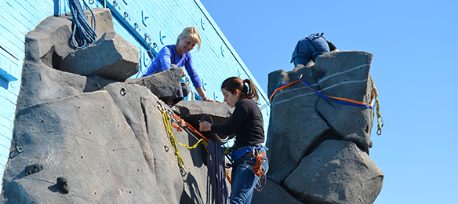
So Many Instructors! So Many Opinions!
One of the things I frequently hear is that it's hard to ensure consistent training from the instructors in our courses. Some people worry this confuses students (and we know from surveys that sometimes - but not always - it does). Others view this as a strength of the organization because it provides students with more than one technique for solving a problem in the outdoors and encourages critical thinking (a best practice - as long as bottom-line safety precautions are conveyed).
Here are some tips things from a few of our best instructors to make sure everyone is on the same page:
- Train the trainer sessions: This is particularly useful for courses where instructors help at multiple field trips. These can be fun social events to get people excited for the season and provide a space for discussion about the skills being taught.
- Sending an "instructor email:" A few days before the course, send an email to your instructors outlining the curriculum to be covered. You can also encourage instructors to send course leaders questions prior to the trip. It can also help to "bcc" instructors on the email sent to students so they know what the students have received prior to the trip. (Tess highly encourages this.)
- Have instructors arrive early to review skills: The designated leader should clearly outline the primary way skills should be taught prior to students arriving (if there are disagreements about this, avoid having these discussions in front of students). The leader can acknowledge the many ways to teach a skill with the instructors, but explain that your goal is to avoid overwhelming students until they've mastered the primary method. If students ask about alternatives or seem to be catching on quickly, additional methods are better discussed at that point.
- Explain the reasons for any variance from what is being taught: If you discuss alternative methods as an instructor, make sure you can explain your reasoning in a clear manner. Otherwise consider not bringing it up. When students are given alternative ways to set up a system without good explanations for the pros and cons, it can make it harder to process what seems like a jumble of methodologies for a new skill they aren't familiar with yet.

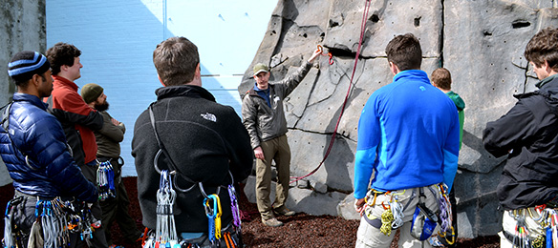
Progressive Climbing Education Project: Still Seeking Input
Mountaineers board members, staff, and CEO Tom Vogl joined climbers of all types to engage in a series of listening sessions held in Tacoma, Everett, and Seattle the week of June 13. The board has invested in the project to pinpoint strategies that can enhance our suite of volunteer-led climbing programs. Some objectives include:
- Making it easier and more fun for volunteers
- Facilitating volunteer recruitment
- Appealing to young, new climbers (especially those coming out of the gym)
- Offering advanced options for our highly skilled volunteers who seek more challenges
We're not trying to reinvent the wheel; we've got a good thing going. But we also recognize that the world is a very different place than it was even 20 years ago and what got us here won't necessarily take us to where we want to go. The long-term goal is to work with our volunteer climbing leadership and partners in the community to identify, reinforce and support the things that are working, tweak things that need tweaking, add things that will make things easier or more relevant, and remove things that are in our way.
If you missed the listening sessions or want to provide even more input, we want you to fill out our survey now! As this process unfolds, you will be able to stay updated with this link: https://www.mountaineers.org/pce.

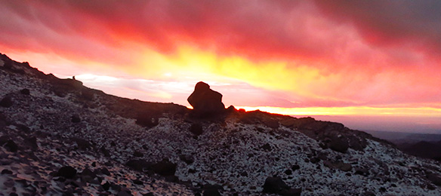
Can the Outdoors be a "Politics-Free Zone"
When speaking about societal privileges, some members have said things like, "everyone is equal in the outdoors" and that they "go outside to get away from the politics in my real life." These statements come from well-meaning perspectives, but can also ignore the experiences other people bring with them to the outdoors.
For some, certain ways of expressing these ideas can be off-putting. They can make a person with different experiences feel unwelcome. Journalist Jamelle Bouie explains how "color blindness" can actually perpetuate the "isms" we want to eradicate. She writes "...millennials have a hard time talking about race and discrimination. Although 73 percent believe that we should talk 'more openly' about bias, only 20 percent say they're comfortable doing so... A generation that hates racism but chooses colorblindness is a generation that, through its neglect, comes to perpetuate it."
Being inviting and inclusive sometimes requires us to engage in discussions we find uncomfortable. Here are 3 tips for people of any dominant culture to consider when having these discussions.

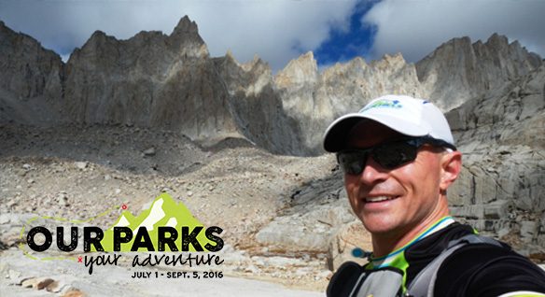
Our Parks | Your Adventure
Join us for Our Parks | Your Adventure, our adventure-based fundraising event to inspire outdoor enthusiasts to take on exciting adventures in our National Parks. This is your chance to pick up a guide book and lace up your boots or grab your kayak to celebrate the National Parks Centennial while helping help us raise $40,000 to get youth outside and into our National Parks. The event runs July 1 - September 5, 2016 and will end with a big party to celebrate your success!
Adventure means different things to different people, so you can choose your Mountaineers-esqe adventure: climbing, hiking, photography, kayaking and more. The opportunities for adventure are endless in a National Park. And no adventure is too big or too small, so choose your adventure and join us!
Click here to learn more and to sign-up for Our Parks | Your Adventure!

Quick Hits
- “My Branch” is now an option when you click your name on our website! This will take you straight to your branch’s home page and more rapidly connect members with your branch's programs.
- Climbing Gear Inspection Tips: Vetted by Outdoor Safety Institute and presented by Petzl, find gear inspection tips + more resources to ensure your gear does its job. Read more here.
- Next up at the Kitsap Forest Theater: The Little Mermaid! Take the kids (or someone else’s - get permissions though!) and see how unique and impressive our very own outdoor theater is!
- Don’t Ignore Your Member Benefits: There are, literally, too many to keep track of sometimes. We work hard to put money in your pockets – go get it! Review them all here.
- “Refuges,” “Parks,” “Historic Sites,” and “Wilderness Areas” Oh My: Ever look at a map and see a land-use designation you’d never heard of? Here’s a cheat sheet for understanding the patchwork legal designations we use to protect our public lands on a federal level.
- 2016 Outdoor Leadership Seminars: Registration opens on July 1 for the Outdoor Leadership Seminar in Seattle and Taoma. There will be two one-day seminars offered this year: Saturday, September 10, and Saturday, October 15th in both Tacoma and Seattle. Successful completion of this seminar earns an Outdoor Leadership badge, and is often a requirement for becoming a leader. They are also looking for instructors!
- Coast Guard App for Sailors and Sea Kayakers: Share a float plan with friends, report pollution, check weather at specific NOAA buoys, check the rules, summon help if you can’t use your radio, etc. etc. Learn more here.
- Check your email lately? If you have a trip listed with leader’s permission please make sure you respond to email requests. If your out in the backcountry for a few days, setting an auto-reply can be helpful. Also if you aren’t going to be responding to requests until a certain time before the activity, state it EXPLICITLY in your leader’s notes. No response is not only a poor experience for our new members, but it almost guarantees additional email(s) to you as the leader. Those who don’t comply will be designated next year’s committee chairs and chained to their computer for the rest of the summer.
Stay Safe Out There!
Interesting Stats:
- Membership: 11,561
- Number of leaders who led trips in May: 279
- Number of participants in activities in May: 1,522
- Number of Leader Badges Issued in 2016: 171 (37 of which have been in backpacking, which saw the largest growth in activity leaders)
- Miles Traveled: The scramblers lead the climbers in "miles traveled" this year by only 67 miles (12,708 vs. 12,641)

