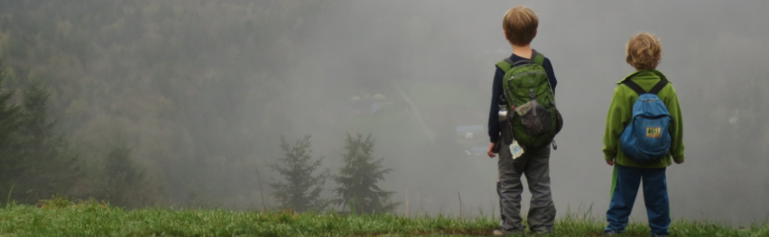
Cayesh & Diran, West Tiger 2013. Navigating in limited visibility.

Pre Trip Plan: Wilderness Navigation Workshop
Most trips into the backcountry are safer and more enjoyable with thorough pre-trip work, including navigation. Your instructors expect you to complete some tasks before the Workshop. You’ll have different planning tasks before the Fieldtrip. Complete and bring this sheet.

Navigation Tools Checklist
☐USGS Index & Baring 1:24000 maps w/ your name in upper right corner. Available that night at bookstore
☐One gallon Ziploc bag (for your maps)
☐Baseplate, declination adjustable compass from recommended list. Tape on your name. Attach lanyard.
☐Wilderness Navigation 3rd Ed 2015, Burns & Burns. Read at least Ch 1-5.
☐Headlamp w fresh batteries—the light is not good for close work
☐2 sharpened #2 pencils or mechanical pencil
☐“Pink Pearl” type eraser
☐Optional small magnifier and/or reading glasses
☐Optional SmartPhone to later load free (or nearly) navigation apps
☐Optional GPS tool or app (if already in hand)
☐Optional Altimeter or app (if already in hand)

Find and Do
☐Find the tiny, brass set screen on your rotating compass housing. Find the tiny screwdriver on your lanyard. Find the tiny black (usually) arrow that is the south end of your other end of your orienting arrow (p34 Burns).
☐In dim light, try your headlamp for map work. (Hint: Light is not ideal at workshop or fieldtrip.)
☐Set your declination to 16 degrees East by turning the tiny set screw with your tiny screwdriver (p48 Burns). Big trouble? We’ll help you upon arrival!
☐Find the tiny, blue UTM tick marks around the edges of your Baring map (p24-26 Burns). You’ll connect them upon arrival.

Work these 8 exercises
>>Burns & Burns Appendix, p178-179 3rd Ed; p128-129 2nd Ed.<<
1. Geographic features: A______ D______
H______ K______ L______ P______
U______ V______ Z______

2. Distance: _____Miles _____Feet ____Meters

3. Distance: _____Miles _____Feet ____Meters

4. Elev: G____ F____ E ____ B ____ W____

>>For help, see p109-112, Burns & Burns 3rd Ed; p74-77 2nd Ed<<
5. Grade of slope: ______________

6. Grade of slope: ______________

7. Direction of slope: ______________

8. Bearing of slope: ______________

Your Name: _____________________________

Year Joined The Mountaineers: _______
Also Enrolled in:
☐Basic Climb ☐Alpine Scramble ☐Snowshoe ☐______

(Rev 19Oct2015/Seattle Nav/ph)

