
Navigation Northwest
A Quarterly Publication of the Seattle Navigation Committee
Volume 7, Number 1 Spring 2019

-- Navigation Northwest Spring Features --

SPOT Double Failure -- A Reliability Discussion Bruce Crawford
Paper or Gaia at Night in the Greenbelt? Peter Hendrickson
Seattle’s Navigation 3.0 Pilot Nears Completion Editor & Michael Hutchens
Editorial: Is Software Eroding our Navigation Skills? Editor
Tracking -- Being High is Generally Better Bruce Crawford

Courses, Classes, Apps, Gear & Links
Other Branch and Club Navigation News and Classes
Wilderness Navigation Course 2019 Classes
Smart Phone and Dedicated GPS 2019 Classes
Introduction to Map and Compass 2019 Classes
Find Free Altimeter & GPS Apps Lynn Graf, Brian Starlin & Emma Agosta
Navigation Gear, Apps & Links of Interest Pat Podenski
Mountaineers Compass Recommendations for 2019 Navigation Committees
Seattle Program Center Compass Calibration Station Bob Boyd

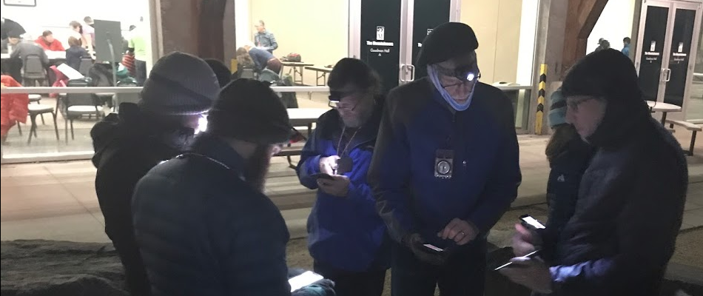
--Wilderness Navigation 3.0 workshop adds GPS outside to map & compass inside.
SPOT Double Failure – A Reliability Discussion
By Bruce Crawford

Local media reported an unrelated February double rescue with a failure to send SPOT SOS signals on Mt Baker, even though the devices were otherwise working. Reading the news articles, it said they suffered multiple failures but didn’t say how. I was not sure if we would get more details, but could already list the failure mechanisms I know of, and also how I use my beacons differently than most people so I can at least retroactively see if they are working.
https://www.kiro7.com/news/north-sound-news/nas-whidbey-helicopter-crew-rescues-two-snowmobilers-in-separate-crashes/923142305

Potential failure list
>>Subscription not paid. Unlike cellphones, you can’t dial 911 without an active plan.

>>Batteries not correct type or dead. Even if they are good when you set out, you must keep the units warm enough, say in an inner pocket, or nested in the fur of a running dog.

>>Don’t know how to use. I use my units in tracking mode every weekend, so yeah, I can quickly get them working. Also, this gives me feedback on how well they work when I download the recorded positions later. So I know their weaknesses.

>>Limited sky visible. It isn’t like texting, you have to wait for a visible satellite. I’ve tried to explain the layouts of the satellite constellations to people and what this means in terms of valley orientation, but have had limited success. In short, being stuck in a well with only a small circle of sky is worst. North-south running valleys are second worst East west valleys third worst. Alternatively, there are apps which show satellite positions. I will work on this a bit more. A speeded up video of the constellations moving really drives the points home.

This link to a discussion of the SPOT failure on Mt Baker confirms the two units worked, except for the SOS buttons. https://www.pilotsofamerica.com/community/threads/spot-failure.117299/

According to the comments, if you want to test a SPOT in SOS mode, you can contact SPOT support, fill out a form, then wait for them to call and guide you through a test. The comment said it took a couple of weeks to go through the process. It doesn’t sound like SPOT is chasing this down.

The link is to a pilot’s forum, and most people commenting appear to have multiple units to mitigate failure. That is my basic strategy: SPOT, InReach and ResQLink+. I did an analysis of tracking on our 16 mile, 1800 ft gain, 7 hour skijor [dogs pull skier] loop in March, and the SPOT (5 minute tracking) successfully sent about 82% of the expected points, and InReach (10 minute tracking) sent 95%. Missed points are, as you’d expect, in valleys. My multi-unit strategy carries no weight penalty for me, because the dogs are carrying the extra units.

I leave the units on and in tracking mode and find battery life is good with minor end of day recharging when out at temperatures above 0 degrees F. Though a musher in a Montana race reported his InReach went dead in -40 to -50 degree F temperatures. But he hangs his InReach on the sled while my InReach and SPOT are attached to the dogs’ harnesses at the back of their necks nestled in their fur under their reflective vests.

One of my summer activities will be sewing hand warmer pockets onto the device holsters I’ve made. But I think my dogs may object to those heat sources. My PLB is typically in an inner pocket with a hand warmer and my cell is in an exterior pocket with two hand warmers when the temperature gets in the teens or less. No problems so far.

---Bruce Crawford is a veteran wilderness navigator who brings surveyor practice and an engineering career to bear on wilderness way finding. A musher, he is a stalwart of the Seattle Navigation Committee. Contact him at bikejor@me.com.

********************************************************************************************

Paper or Gaia at Night in the Greenbelt?
By Peter Hendrickson

Night hikes in the city are a personal favorite, something of an obsession the past 3 years in Seattle as a leader and earlier in Portland as a participant. Every new route is mapped and pre-hiked solo before the outing, usually on a sunny day. I develop a custom route in Gaia, taking inspiration from three local guidebooks.

Most new hikes require a few tweaks but the routes change only slightly to reach the 4 to 6 mile distances walkable in 2 to 3 hours. Before the Mountaineers (BTM) I used Google Maps to plan Seattle walks that led to a regular column in The Phinney Review. The pattern was 1) search online at home, 2) use a highlighter on a printed copy, 3) walk with map in hand, 4) write the turn-by- turn column, 5) walk again with Nancy attempting to follow my directions, 6) edit and publish. I never looked at the older smart phone while walking.

It was even easier in Portland. The Mazamas night hike leaders led the way on Tuesday and Thursday nights (6 to 8pm) on every varying routes in the west hills and we followed. I was able to recreate a few routes when leading friends on day hikes.

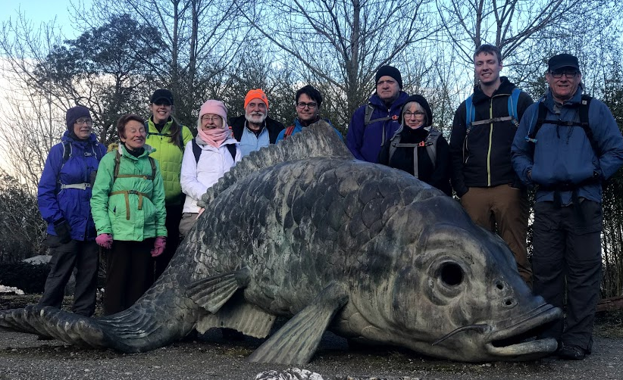
Figure 1. Greenbelt night hikers meet Seattle Chinese Garden fish.

The current night hikes generally provide few navigation challenges unless we dip into forests and ravines – more than you might imagine in Greater Seattle. Last month I had to twice test hike a Craig Romano (Urban Hikes Seattle, 2018) Duwamish Trail & West Duwamish Greenbelt 5.5 mile route. The first route failed on account of a sketchy Greenbelt trail and no safe crossing of West Marginal Way. The second route failed on account of a cliffy hogback ridge not easily identified from contour lines. And the third go, this time with 10 other hikers, presented fresh challenges. I’d failed to check the soil composition during a dry spell. Rain turned the clayey soil slick as hog snot (Figure 2). I had ignored the 1889 history of brick making using shale clay from the banks of the Duwamish River.

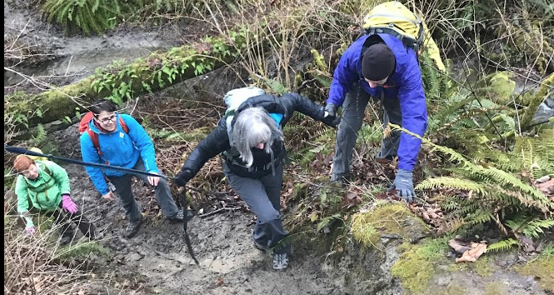
Figure 2. One hand on the webbing and another for (related) fellow hiker.

Turns out it is not paper OR Gaia at night. Both are needed. The first to display the scope of the hike and to help create a (somewhat) durable mental map. The paper is also useful when showing the route to participants. Gaia generally nails point position. And a quick compass check gets us pointed the right direction. In short, city hikes at night demand facility with several tools. Including historical research

--Peter Hendrickson worked (and climbed) 1971-73 in Quito, Ecuador where the only available topo maps required visits to the Instituto Geografico Militar. We enlisted friends with local knowledge to join us. Map scarcity was reinforced by fears of revolution -- fully realized in 1972 EcuadorCoup.
Contact: p.hendrickson43@gmail.com

**************************************************
Seattle’s Navigation 3.0 Pilot Nears Completion
--Editor & Michael Hutchens

Cleary the Saturday/Sunday March 16/17 Seattle Navigation 3.0 field trips to Heybrook Ridge were among the most challenging in my decade of involvement—even without rain. On Sunday we were 67 students and 20 instructors, one of the larger recent trips and barely enough instructors to cover safety issues. Further, the most experienced instructors were spread over two days, leaving Sunday with only 5 committee members (3 somewhat weary from the prior day), 3 seeking equivalency and the remainder not so experienced – most unknown to the Day Lead.

Field Trip 3.0 Module Four development did not anticipate such difficult conditions or such a small pool of 3.0 experienced instructors. Accommodations were made ad hoc over several components to reduce risk. We eliminated the stump field exercise and final problem launch from high on Heybrook Ridge – too much snow.

Turned out there was opportunity for a thoughtful mix of tools (compass and gps) when encountering the combination of deep snow and challenging blowdown. If we instruct single tool practice rather than shifting tool use to meet conditions, we ignore actual practice of skilled navigators. Instructors spread out launched students by offsetting from the fixed GPS routes. Catchers did not know the accommodation was made and were still giving the traditional response to distance from the target signs. Hence, most students were slightly offset to the east but still within two signs. Had the offset been known and acknowledged, greater jubilation might have resulted. The April 13 field trip was rainy but went smoothly, with an early wrap-up. One spring field trip (April 28) remains.

Students have completed Modules 1, 2 and 3 (eLearning, GPS online and in-person workshop) with near 100% turnout. Course administrator Michael Hutchens reported:

>>Total completion: 262 completed / 321 (285 currently registered + 36 cancelled from the main course) students = 82%.
>>Individual session number started off around 94% for the first session, to about 60% for the last session, for an average of around 80% success per session for 5 sessions.
>>GPS vs. eLearning (LITMOS) were pretty much that same, and followed the same trending.

Other interesting items:
1. Even with “nudging,” 60 percent of the students who completed the course did it in the last 3-4 days.
2. Deadlines WORK. Rather than 1 big “free for all”, the individual session tracks did their job. Easier on instructors also since they could come in, do their 2 week tour of duty, then the next batch takes over. I also think 2 weeks is plenty of time to complete this work.

3. We need more time between the end of online sessions and workshop starts as I had a lot of last minute roster cleansing for workshops (students that signed up for a workshop but did not finish online and had to be removed from the workshop roster). There were no exceptions given for the workshops, and hopefully it helped with having “more” prepared students for the workshop. Brian has next year’s online starting in December 2019, which I think will help a lot.

4. I created two FAQ documents for the course: one for students, and one for online instructors, mainly for online content and course structure. I don’t know if this was of any benefit or not, but the number of questions I received did drop somewhat after I posted them J.

There are content topics to discuss in the offseason, and meetings are already scheduled. There is one more online round scheduled for the fall, which can accommodate the remaining registered (the portion that want to finish) plus the 71 people on the course waitlist. The number of students taken from the waitlist will be mostly driven by the fall workshop and FT capacity. We will work on that after the last April FT.

--Michael Hutchens is course administrator for Seattle’s Wilderness Navigation class and lead on eLearning plus e-GPS modules.. Lead Patricia McDonald, with Steve McClure, Stevie Russell, and Otto Gruele have developed the Workshop Module. Peter Hendrickson is lead on the Fieldtrip module with support from many. Committee Chair is Brian Starlin.

**************************************************

Editorial: Is GPS Eroding Our Navigation Skills?
--Editor

New York Times Opinion March 16, 2019
“Another way that automation can come to grief is when the system works as designed but the pilot becomes confused and does the wrong thing. In 2009, Air France 447 was over the middle of the Atlantic en route from Rio de Janeiro to Paris when its speed sensors became clogged with ice and stopped feeding data to the autopilot.

The autopilot then switched itself off and handed control of the plane over to the pilots, as it was designed to do under such circumstances. The pilots, however, became disoriented and one of them inadvertently pulled the plane’s nose up, so it climbed and lost a dangerous amount of speed. Worse, the pilot didn’t realize that with the autopilot off, the plane’s computer was no longer preventing the wing from aerodynamically stalling. In less than five minutes, a perfectly good airplane went from cruising at 32,000 feet to hitting the ocean.

In both kinds of events, pilots find themselves having to suddenly figure out why a complex system is no longer acting as expected and then take quick action based on that analysis. Moments of high stress are precisely those in which the human brain is least equipped to figure out complex situations.
The best way to deal with emergencies is to train and practice beforehand, so that response becomes automatic. Ironically, by turning over the mundane stick-and-rudder aspects of flying to computer automation, pilots are deprived of the opportunity to continually practice. This leaves them without the mental automation that might save them in a crisis.

Unfortunately, in the case of the 737 Max, it seems that Boeing has built a plane with a fundamental aeronautical issue that it thought would be resolved by adding a new automated system. But the company convinced airlines and the F.A.A. that the planes were essentially interchangeable with earlier models of 737, and therefore pilots who were already trained in flying older 737s would not need comprehensive additional training on the new system. The F.A.A. agreed with that conclusion. This would, among other things, save money on crew training and maintenance costs. That has proved to be a terrible miscalculation.

In the wake of a double disaster, Boeing has announced that it will release a software upgrade for the 737 Max. The company may indeed have solved the problem. It may be that the 737 Max will return to service with the patched software and never again suffer a mishap.”
....
Each day brings fresh revelations about the twin crashes. As wilderness navigators, let’s not count on our GPS “autopilot.” Rather, let’s keep fresh our complete navigation tool set through routine use.
*************************************************
Tracking – Being High is Generally Better
By Bruce Crawford
I use my satellite trackers unlike most people. I put them in tracking mode and put them on dogs. This means I see how the trackers perform on a regular basis. Figure 1 is an example trip .jpg with my Gaia track (dark green), the InReach track (blue) and the SPOT track (red). I loaded all the gpx’s into CalTopo.

Figure 1. Musher track near Meany Lodge, Stampede Pass.

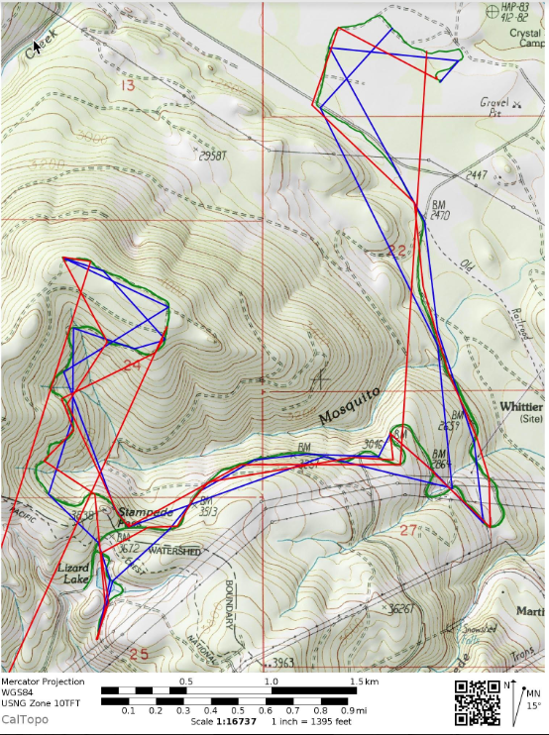

If the vertices of the trackers are on the green track, all is good. What you can notice is that SPOT placed one point very far southwest of my actual track. This is not unusual. Every so often there is an outlier point with SPOT. Long legs either mean we were moving fast, or more likely, messages didn’t get to the satellites.

I’m fairly impressed with how well both trackers did. They are supposed to send the position every 5 to 10 minutes. The trip as a whole lasted over 5 hours, so you can see not all messages get through. Being high is generally better.

--Bruce Crawford is a veteran wilderness navigator who brings surveyor practice and an engineering career to bear on wilderness way finding. He is a stalwart of the Seattle Navigation Committee. Contact him at bikejor@me.com.

**************************************************

News from Branch Navigation Leaders

Foothills – Alan Davey, Co-Chair
The Foothill Navigation Committee will offer Wilderness Navigation this spring (March/April). We're looking for committee members, instructors and instructor assistants to help make this initial course offering a success. Committee members have helped with setting strategy, course development and course delivery. Instructors and instructor assistants will provide hands-on student support as well as helping with the hundreds of other tasks required to make a course successful. Our new fieldtrip site is in the Raging River State Forest off Hwy 18.
The spring 2019 course follows last year’s Seattle Wilderness Navigation template. So there is little new content for experienced instructors. Fall 2019 we will enhance our course by adopting Seattle Wilderness Navigation 2019 (Nav 3.0) template which includes eLearning and incorporates GPS content.

Foothills will offer an 8-week online course on Digital Navigation and Trip Planning this Fall. This course aims to keep students up-to-date on the latest navigation developments and trip planning best-practices in the ever-evolving digital space. Whatever your preferred activity or current level-of-knowledge, this series is designed to take your skills to the next level. Better planning translates to better outcomes.
Contact Alan at awdavey@hotmail.com
Everett -- Joel Heidal, Chair
Late denial of a DNR permit closed Everett our of their usual area with cancellation of a planed March 30 session (workshop plus field trip).

Bellingham -- TBD

Kitsap – Troy Hubbs, Chair

Tacoma -- Rick Finkle, Chair
No change from traditional workshop and Irish Cabin field trip.

Olympia – Mike Kretzler, Chair
Spring course is on schedule with a Black Hills field trip this month.

Mazamas (Portland) -- John Godino, Lead
I’m thinking of offering a more advanced navigation and trip planning workshop sometime this spring, something that brings together massaging different GPS tracks into one, adding weight points for relevant things you might need, bring it into Google earth, importing to Cal topo, and finally exporting as a single GPX file. Dates and itinerary have not been set, but I know there’s interest for a class like this. Regarding those phones -- Really all tools in one smart phone?

Bench tests support update for required compass models
Article first published July 2018
Seattle navigation’s compass guy, Bob Boyd, has completed bench tests of three preferred compass models for Wilderness Navigation instruction. The registered land surveyor used his home test station to challenge Silva, Brunton and Suunto performance. Updated Mountaineers-wide compass requirements follow on the next page. --Editor

Compass Test | Silva Ranger  #1 & #2 | Brunton TruArc  #3 & #4 | Suunto MC-2  #5 & #6 | Other Remarks  Both USGS Suuntos are for the US
Packaging | Overdone | Overdone | Easy Open
Shipped By | Amazon | Back Country | Amazon
Freezer Test | Good | Good | Good
Opens | Easy | Easy | Easy
Hinge | Good | Good | Good
Lanyard | Short & pulls apart | Short but good | Short but good | Silva has a two-piece measuring lanyard that can pop apart, loosing your compass.
Scales | UTM & others | Scales but not UTM | UTM & others
Magnifying Lens | Yes | Yes | Yes
Leveling Bubble | No | Yes | No
Information Cards | Yes | Yes | Yes | These cards have miscellaneous information & scales.
Bezel Turns | Good & Very Hard To Turn | Too Loose | Good | Compass #2 took two hands to turn. The Bruntons will almost turn themselves. Compass #5 glows in dark.
Declination | With a screw driver | Friction | With a screw driver | The Brunton system is hard to master
Bezel Centered | Yes | Yes | OK | Keep Suunto bezel pushed forward.
Mirror | Good | Good | Some warpage | The Silva has an X to look at. Suunto mirror makes a poor signaling device.
Needle Length | 1 - 7/16" | 1-1/8" | 1-5/16" | Longer is better to align.
Global Needle | No | Yes | No | The Brunton global needle has a lot of needle dip, which can be hard to align.
Orienting Lines | Good | Good | Yes, but short | First remove white plastic from bottom of the Brunton bezel.
Set A Bearing | Easy | Too Easy | Good | Compass #2 has a still bezel. Bruntons almost turn themselves.
Pointing Error | 1º Lt & Good | 2º Rt & 1º Rt | Both <1º
Clinometer | Yes | Yes | Yes
Mountaineers Required Compass Features
Wilderness Navigation & Other Courses
Revised July 2018
1. Adjustable declination: This feature simplifies map and compass work. Most compasses with adjustable declination have an adjustment screw, usually brass or copper-colored, and a small key attached to the lanyard. Some have a ‘tool-less’, pinch-to-adjust feature.
- All students MUST have a compass with adjustable declination. The presence of a declination scale does not guarantee that it can be adjusted.
- Even if you already have a compass without adjustable declination, you may not use it in this course. Experience indicates that such compasses detract from the learning experience.
2. A transparent rectangular base plate with a direction of travel arrow or a sighting mirror.
- Transparency allows map features to be seen underneath the compass.
- A rectangular shape provides straight edges and square angles to plot on the map.
3. A 0 to 360 bezel (the rotating housing) marked clockwise from 0 to 360 degrees in increments of two degrees or less. Bezels should be large to allow use with gloves - the larger size also improves accuracy. Do not get one marked in 0-90 degree quadrants OR one marked in O-6400 mils!

4. Meridian lines: Parallel 'meridian lines' on the bottom of the interior of the circular compass housing rotate with the bezel when it is turned. Longer lines are better. Meridian lines run parallel to the north-south axis of the bezel, however turned, for use with a topo map.

5. A ruler and/or gradient scale engraved on one of the straight edges, used for measuring distances. In the U.S. 1:24000 scales (rather than 1:25000) are preferred. Both are acceptable.

6. A 3 to 4-inch base plate. A longer straight edge makes map work easier.
Additional recommendations
• A sighting mirror in the cover: May reduce error introduced when moving compass from eye-level after sighting to waist-level for reading the dial. Protects the bezel.
• A liquid-filled housing: Reduces erratic needle movement (common on better compasses). In some cases, steadying the compass needle can be difficult
• An inclinometer: A gravity driven arrow that allows you to measure slope angle.

Current favorites: Silva, Suunto, and Brunton are favorites. All have adjustable declination. Their quality and usability varies, so keep any receipt. We have unfortunately seen many defective compasses in the past.

Maker | Models | Features + | Features - | Vendors | Cost
Silva of Sweden | Ranger CL515  Ranger 2.0 | Slope card,  New, more features | Still available? | Cabela’s, Online | ~$55  ~$50
Suunto of Finland | MC-2  M3-D Leader  MC-2G Navigator | Northern Hemisphere  Mirrorless  20 degree tilt margin | Lacks clinometer | REI, Online | ~$40-64  ~$44  ~$95
Brunton of Colorado | TRUARC 15*  TRUARC 5 | *Global needle, mirror  Global needle, 51 Grams  Luminous | Bezel may pop out  Bubbles? Mirrorless | REI, Cabela’s, Online | ~$50-60  ~$20-30
Manufacturers make continuing improvements and corrections in models. Model variations and designations proliferate – insist on features 1 to 6 above. Manufacturers make continuing improvements and corrections in models.
(Rev 3July2018/ph bb bs jl)

Wilderness Navigation Course Offerings—Seattle 2019*
The revised Wilderness Navigation 3.0 is focused on wilderness/back country travel including off trail navigation to meet requirements for Alpine Scramble, Basic Climbing, Snowshoe and BC Ski students (and others). Essential tools are maps, altimeters, compass, GPS and emergency communicators. The four components are (1) eLearning Workshop, (2) GPS online module, (3) In-Person Workshop and (4) Field Trip. Completers receive both Wilderness Navigation and GPS Navigation badges, reflecting the emphasis on using the expanded navigation tool set. Fee.

Lead course administrator is Michael Hutchens.

Dates 2019 | 1 - eLearning  2 - GPS Module | Date & Day | 3 - Workshop  4 - Fieldtrip
Feb 26 to Mar 12  Feb 27 to Mar 12 | Online  Online | Thursday, Mar 14  Saturday, Apr 13 | Program Center  Heybrook Ridge
Mar 12 to 25  Mar 13 to 25 | Online  Online | Tuesday, Mar 26  Saturday, Apr 28 | Program Center  Heybrook Ridge
Sep 10 to 24  Sep 26 to Oct 10 | Online  Online | Tuesday, Oct 15  Saturday, Nov 9 | Program Center  Heybrook Ridge
Introduction to GPS & Trip Planning Course—Seattle 2019*
Interested in learning to use your smart phone as a wilderness GPS? Maybe you’ve had a Garmin for years or the Gaia app on your smart phone and want to get the most out of them. This one evening course is revised. An online presentation with exercises is viewed and completed (4 to 5 hours) before the class. Applications are Gaia and CalTopo. Prior completion of the Wilderness Navigation course is strongly encouraged. Fee and Badge.
Course lead administrator is Michael Hutchens.
Dates 2019 | Location
Thursday, April 18 | Seattle Program Center
Wednesday, May 22 | Seattle Program Center
Friday, September 27 – GPS only | Online Classroom Details TBD

Introduction to Map & Compass – Seattle 2019*
The Seattle Navigation Committee scheduled five 2019 Introduction to Map and Compass dates at the Seattle Program Center from 6:30 to 8:30 p.m. Instructors are drawn from the pool of Wilderness Navigation Course teachers.

This Getting Started introductory class does not satisfy the navigation requirement for Alpine Scramble, Basic Climbing, Snowshoe or Backcountry Ski. Baseplate declination adjustable compass loaners are available for the class. Fee, no badge.

Lead course administrator is Nina Crampton.

Intro to Map & Compass | Location
Wednesday, April 24 | Seattle Program Center
Monday, June 10 | Seattle Program Center
Monday, August 12 | Seattle Program Center
Monday, September 9 | Seattle Program Center

Other Seattle 2019 Navigation Seminars/Clinics*
Seminars/Clinics | Dates
Instructor Training Elearning – No fee Program Center  Lead seminar administrator is Paul Thomsen. | Nov 15  Seattle Program Center
Mentor Sessions Wilderness Navigation – No fee | Apr 11, Nov 7
Wilderness Navigation Equivalency – No fee | Rolling enrollment
Lead equivalency administrator is Lynn Graf

Other Branches 2019 Navigation Courses*
Branch | Course | Dates
Everett | Basic Navigation Workshop & FT Camp Edward | Dates TBD
Everett | Wilderness Navigation eLearning Option | Under Consideration
Foothills | Staying Found | April 28, May18
Foothills | Wilderness Navigation | April 27
Foothills | Digital Trip Planning & Navigation | TBD
Foothills | Navigating in Winter Terrain | Date TBD
Foothills | Wilderness Navigation Equivalency | Contact TBD
Kitsap | Both series have Elearning Wkshp Option | Dates TBD
Kitsap | Wilderness Navigation Lectures Option | Dates TBD
Kitsap | Wilderness Navigation Wkshp/Field Trip | Dates TBD
Olympia | Navigation Lectures 1 and 2  Lacey Community Center | Tues Apr 16 & Thurs Apr 18
Olympia | Navigation Field Trips  Kennedy Creek, Black Hills | Sat Apr 20 or Sun Apr 21
Tacoma
Tacoma | Wilderness Navigation Lectures 1 & 2; Field Trip | Apr 16, 23; Apr 27
Tacoma | Wilderness Navigation Lectures 1 & 2; Field Trip | Sep 11, 18; Sep 21
*Check mountaineers.org for up-to-date listings.

Mazamas (Portland, OR) 2019 Navigation Instruction*
Portland | Navigation Skill Builder Class – Videos, Wkshp, Field work | TBD
 | Wilderness Navigation Smartphone GPS (Gaia) | TBD
*Northwest climbing clubs support similar goals for exploration, learning and conservation. Reciprocity is routinely granted across state lines. Mazamas lead navigation instructor is John Godino, contact johngo.pdx@gmail.com.

Contact Information Other Northwest Mountaineering Clubs

Organization | Web address | Notes
The American Alpine Club – Northwest Region | https://americanalpineclub.org/cascade-section | Cascade Section has a Washington & Oregon focus  Facebook presence
BOEALPS, The Boeing Employees Alpine Society | http://boealps.org/about-us/ | Primarily climbing; spring Basic Mountaineering Course
Bushwhacker Climbing Club | https://bwcc.clubexpress.com/content.aspx?page_id=22&club_id=172409&module_id=151320 | Founded 2003. Hike, climb, ski, socialize
Mazamas | https://mazamas.org/ | Founded 1894 in Portland. Mainly a climbing club for those who have already summited a glaciated peak
OSAT, One Step At A Time | http://www.osat.org/ | Melds outdoor activities with recovery; 6 month glacier climbing course
WAC, Washington Alpine Club | https://washingtonalpineclub.org/ | Founded 1916. Many Guye Cabin activities, Snoqualmie Pass

***********************************************************

Navigation Gear, Apps & Links of Interest
Your comments and suggestions are ever welcome regarding the Seattle Navigation website and links in Navigation Northwest. –Pat Podenski, Section Ed

The Apps...
- Gaia has released a rain and snow overlay with 48-hour forecasts.
- AllTrails has a Record Track function for iPhone or Android.

(Following apps first published in June 2017 issue)

Free (or nearly) Altimeter Apps For Smart Phones
By Lynn Graf

 | App Name | Device | Developer | Cost
 | Gareth Altimeter | Android | Gareth Price | free
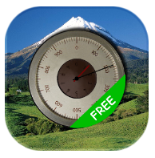 | Accurate Altimeter | Android | AR Labs | free
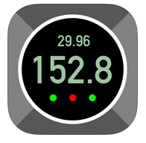 | Pro Altimeter | iPhone | Hunter Research and Technology | $0.99
 | Altimeter Plus | iPhone | Sichtwerk AG | free

Short guide to a few recommended altimeter apps for cell phones
Don’t want to spend the money for a classic wristwatch altimeter, one more gadget? Basically all SmartPhones nowadays have GPS capability. This means that they can pinpoint your spatial position without cell service, which is often spotty or non-existent in the backcountry (and searching for a signal drains the battery, in case you haven’t noticed). Many of the newer models (iPhone 6 and later, for example) also have a pressure sensor. This can be used for extra correction or a cross-check of elevation by barometric pressure (which is what wristwatch altimeters use) but that is not really necessary and requires more frequent calibration.

Here are recommendations for two very basic apps for Android and two for iPhones.

Selection Criteria (not in order of importance): low or no cost, easy to use, no cell service required, no ads, low memory and storage usage, reasonable speed at obtaining GPS signals, clear numerical display, recommendation from Mountaineers member(s) who have used it in the field.
There are many more out there, more all the time, and increasingly with features in addition to GPS-based elevation. We invite you to try them, see how they work for you, and let us know if they don’t work as advertised. If you want additional information, see the article in Navigation Northwest (https://www.mountaineers.org/blog/how-to-pick-an-altimeter) describing a systematic comparison of several Android apps.
Also, The Mountaineers currently has a deal for free use of GAIA Pro that basically turns your cell phone into an advanced GPS device. Check the website under “Benefits” (https://www.mountaineers.org/membership/benefits/instructions-for-redeeming-member-benefits). It is highly recommended but requires time and practice to set up and use efficiently. The Seattle Navigation GPS class features Gaia as the app of choice. Backcountry Navigator, another full-service GPS app, also has many followers. Both are well worth it, in my opinion, but a paper map, compass and altimeter app will get you a long ways, both on and off-trail.

--Lynn Graf is a past Seattle Navigation chair and an active hikes and scrambles trip leader. She is a frequent contributor to Navigation Northwest. Contact her at: lynn.graf@gmail.com.

***********************************************************
Free (or nearly) GPS Apps for Smart Phones
By Brian Starlin and Emma Agosta

Screen Shot | App Name | Device | Developer | Cost
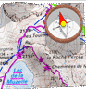 | MyTrails | Android | FrogSparks | Free  Pro €2
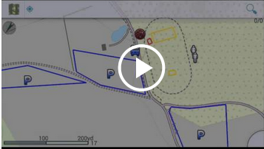 | GPS Essentials | Android | Schollmeyer Software Engineering | Free
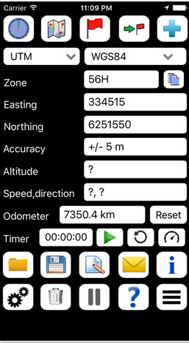 | Handy GPS | iPhone | Anthony Dunk  [Note: Also authored Coordinate Master to convert Lat/Long to UTM] | Free
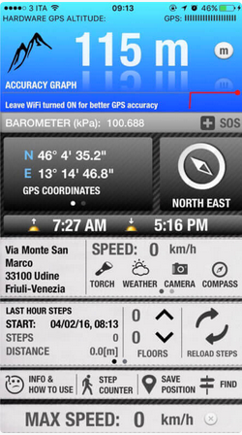 | Altimeter GPS | iPhone | Andrea Piani | Free

Criteria for Android and iOS GPS:
1) Backcountry oriented (Topo Maps rather than street maps)
2) Works offline, in airplane mode, with only the GPS on
3) Can display UTM and Lat/Long
4) Has at least NAD83/WGS84, but gets extra points if it has NAD27
5) Extra points if it's available for Android and iOS
6) Able to save data and send in GPX format
7) Able to import GPX format
8) Accurate (although I believe it's based on underlying GPS hardware)
9) Extra credit if tracks can be shared on a cloud service
10) Free

We used a 10-point scale with higher numbers meaning more of the above features were found. Also, there is a main point we need to make. Gaia is a serious app for backcountry use and has all the features we want. And Gaia Pro is currently free for one year to Mountaineers members .

Android Reviews (Brian)
>>GPS ESSENTIALS (mictale.com) -- 5 points
Only available on Android.
It only uses cached maps, which limits its offline usefulness.
Very robust dashboard, highly configurable.
Limited selection of map sources
The UI is clunky. It uses a thing called "streams" to store data. The Import/Export functions were hidden in the "streams." The track recording was also buried in the stream screens. The Dashboard is great, but the other functions are clunky.

>>HANDY GPS (BinaryEarth) -- 2 points
Great for just displaying your coordinates in various formats. It has very limited maps -- a blank screen, and the Google Maps. The map does not work offline and cannot be downloaded.

>>MYTRAILS (FrogSparks) -- 6 points.
Great selection of maps. I think it has only NAD83/WGS84 because I don't see a Datum setting. Tracks and waypoints can be saved as GPX. The free version can only save the current track, plus one. And can only store 100 tiles at a time in the offline storage. UTM displays on the screen. It's on Android.

>>RAMBLR (Bientus) -- 2 points
This is more of a journaling and trip sharing app than a GPS app. It's very focused on tracking and sharing details of a trip. It has Google Terrain and OpenCycle maps. It can use an offline map. It does not display coordinates, but it can show you your location on the map background. As I said, it's a journaling app.

iOS Reviews (Emma)
Additional features I noticed are under "other features and comments."

>>ALL TRAILS -- 3 points, free
Hiking oriented but by trail (not backcountry). More like WTA app. Works offline. WGS 83/84. Available for IOS and Android. Map overlays (such as USGS topo) are in the Pro version ($29.99/year). No UTM or Lat/Long. Other features/Comments: ability to track a route, keep history etc. Many other apps do this for hiking, biking, running and other sports. I do not believe these are the kind of apps our readers are looking for.

>>ALTIMETER GPS -- 4 points, free.
Not backcountry oriented. Lat and Long: yes. No UTM. Elevation (ft/meters). Accuracy: unknown. Available on both? Some features only work with internet (i.e. choice of map format). Other features/comments: Weather, barometric pressure. Compass heading, Step Counter. Speedometer. Save position. Ads (non intrusive at the bottom, yet one can accidentally click). Find feature to search for location.

>>DECLINATION -- 1 point, free
Not backcountry oriented (map: satellite view). Lat and Long and UTM. Works offline: yes. Accuracy: unknown; Datum: ? Other features/Comments: Declination; Ability to search by Lat and Long. Ads.

>>HANDY GPS -- 6 points, free
Not backcountry oriented. Works offline: yes. UTM and Lat/Long, (plus elevation); Datum: ? Available for both IOS and Android. Able to save data and email : yes. GPX file: no; Accuracy level (+-10m). Other features/comments: nice display: uncluttered; intuitive, user-friendly; key features: Map. Digital Compass. Can save waypoints and email position from within the app. No ads. My favorite among free but cannot compete with Gaia.

>>MAP TOOLS -- 3 points, $0.99
Street oriented; Works offline; Lat and Long and UTM; Datum: ?; GPX format: no; accuracy: unknown. Other features/comments: Not intuitive. Confusing zoom in and out feature. Declination provided.

--Brian Starlin is the Seattle Navigation Chair and a frequent Navigation Northwest contributor. Contact him at brian.starlin@comcast.net

--Emma Agosta is a Seattle Navigation instructor and committee member. A geologist, she is fluent in land forms (and Italian). Contact her at emagosta@gmail.com

And the links …
>> A double treat from John Godino (Mazamas). Here’s a little something I put together for my website. It’s a map of some of the more popular northwest peaks. If you click on the pin for each one, it brings up coordinates, elevation, approximate difficulty rating, and links to SummitPost and Peakbagger.

https://www.alpinesavvy.com/nw-climbing-peaks-map
And, here are similar maps I made for the 100 highest peaks of Washington, Oregon, California, and Colorado. Kind of interesting to see where the high points in each state tend to be concentrated.

https://www.alpinesavvy.com/highest-100-maps

>> The North Magnetic Pole’s Mysterious Journey Across the Arctic
https://nyti.ms/2DTZ7Ep?smid=nytcore-ios-share

***********************************************************

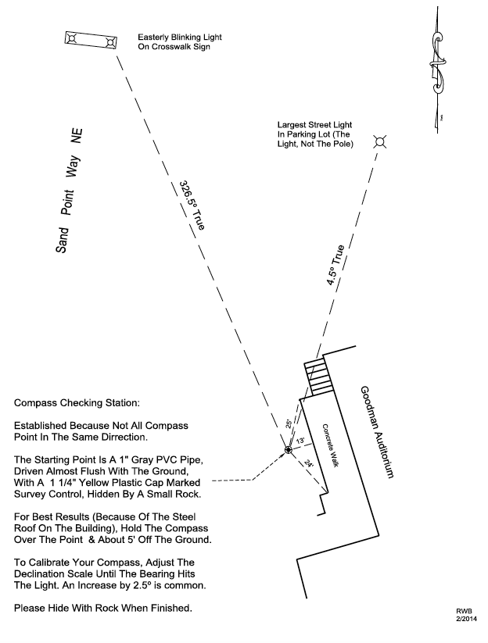
Seattle Program Center Compass Calibration Station

Navigation Northwest Copy and Publish Targets 2019

Calendar 2019 | Copy Deadlines | Publish Dates
Volume 7, Issue 2 | June 1 | Late June 2019
Volume 7, Issue 3 | September 1 | Late September 2019
Volume 7, Issue 4 | December 1 | Late December 2019

Proof Readers: Stevie Russell & Nancy Temkin (some issues)

Inquiries, Contributions, Letters to the Editor to Peter Hendrickson
p.hendrickson43@gmail.com

OK to forward

OK to use with attribution

Email Navigation Northwest to any friends/outdoors partners to distribute

Guidelines for contributor submissions:
--Word doc...Google doc OK but not a PDF
--12 pt Verdana
--Standard margins
--Indicate in body of text where you would like figures/tables etc. to go
--Send figures, tables, photos as attachments or by separate email
--Refer to figures & tables by number in body of text
--No footnotes, header or footer
--Author blurb with preferred email contact address

Kindly contact editor for further information regarding topics, length, tables, figures, deadlines...

“Do not go where the path may lead, go instead where there is no path and leave a trail." --Ralph Waldo Emerson, American writer, 1803-1882

(Rev 22April2019/ph)

