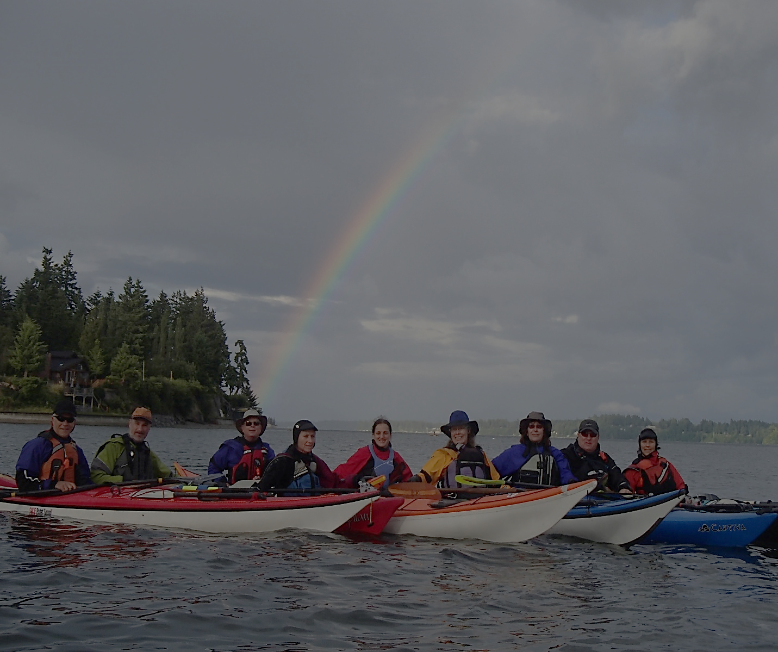
OLYMPIA MOUNTAINEERS SEA KAYAKING
ABOUT US
HOW TO JOIN
SEA KAYAK CLASS
EQUIVALENCY
OTHER TRAINING
WINTER POOL SESSIONS
ESKIMO ROLLING CLASS

WEDNESDAY EVENING PADDLES
SEA KAYAK TRIPS
ANNUAL EVENTS

Sea Kayaking scenes: (some eye candy)

OLYMPIA MOUNTAINEERS SEA KAYAKING

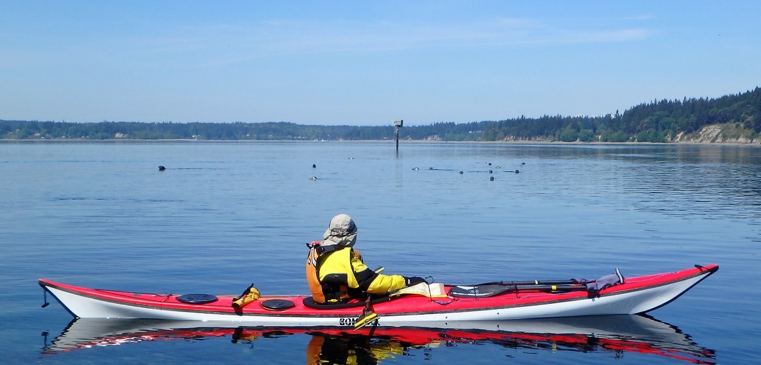

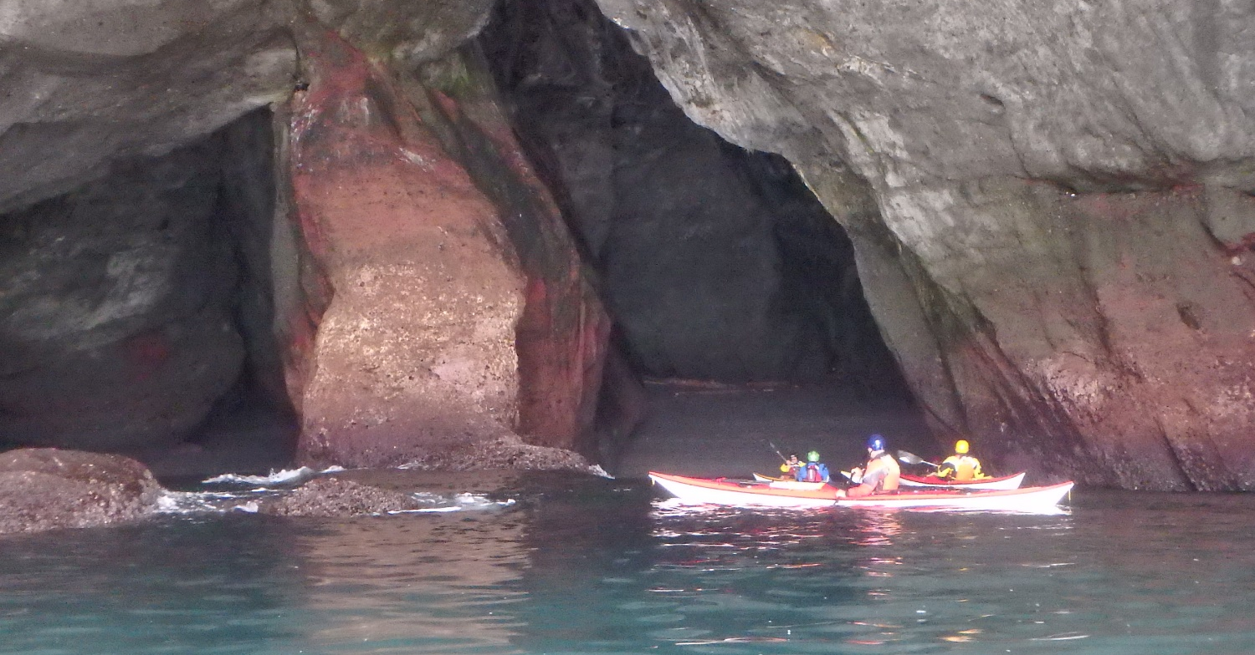

OLYMPIA MOUNTAINEERS SEA KAYAKING
ABOUT US: We are a group of sea kayakers in the Olympia area who are mountaineers and sea kayakers. Our mission is to promote safe and fun sea kayaking for all levels. Home.
HOW TO JOIN: Become a mountaineer: Join the mountaineers
Contact Dan Halsey djhalsey@comcast.net
To paddle with the mountaineers a sea kayaker must either graduate from the Basic Sea Kayaking Course or pass an Equivalency test to prove you have basic sea kayaking skills. Home.
BASIC COURSE: Basic Class Information Interested? Contact: Will Greenough: kayakwill@yahoo.com Home.
EQUIVALENCY: Equivalency Application or contact Brian Hollander :lhotse_h@msn.com Home.
OTHER TRAINING: Basic Paddling technique, Kayak Rolling, Capsize Recovery, Incident Management, Surf zone technique, Carving and paddling a Greenland paddle and other classes are offered periodically. Home.

OLYMPIA MOUNTAINEERS SEA KAYAKING
WINTER POOL SESSIONS: From November to April, usually the second Sunday. Rescue practice and eskimo rolling practice in warm water! Interested? Contact Molly Morse: joggerjoey@gmail.com Home.
ESKIMO ROLLING CLASS: Held in a pool: 3 Pool sessions and one optional evening. Have a personal coach help you learn the kayak roll and radically change your kayaking experience!
Roll Class 2018 Home.
WEDNESDAY EVENING PADDLES: Mid May to September for evening lighted paddles, social gathering, training as desired. Home.
SEA KAYAK TRIPS: Numerous trips offered around the year available for sign up. Olympia Sea Kayak Trips Home.
ANNUAL EVENTS: Summer picnic & paddle. Winter Leader dinner and Trip Planning. Home.

