
Olympia Wilderness Navigation Course
In the Olympia Wilderness Navigation course, you will learn about maps, compass use, GPS use, coordinate systems, terrain association, and route planning. It consists of two online classes you complete in April, an online workshop to ensure you’re ready, and a full day of outdoor exercises and practice. The first online course is an e-learning class that covers maps and their use, compass use, and trip planning. The second is an online slide presentation that covers GPS tools and use. The GPS exercises use smartphone-based GaiaGPS (free and available for both Android and Apple phones), but your own device can be used. The outdoor sessions are held at Kennedy Creek between Olympia and Shelton, in early May. There are no make-up sessions, so be sure of your schedule before registering. Registration closes in mid-March to allow time to purchase compasses and other materials.
A discount is available for Olympia Basic Climbing and Alpine Scrambling students.
Contact Mike Kretzler at mkretzler@comcast.net with any questions.
You will need:
- An approved compass (approximately $70). See next page for details.
- A paper (best, $10) or downloaded (usable) copy of the USGS Baring map.
- The GaiaGPS app (free via Mountaineers Members Benefits and/or have your own GPS device).
- “Wilderness Navigation” (third edition, $17) by Burns and Burns, available to order at sign-up.
To complete the course, you must:
- Complete the online coursework.
- Attend an online workshop.
- Complete the outdoor session exercises.
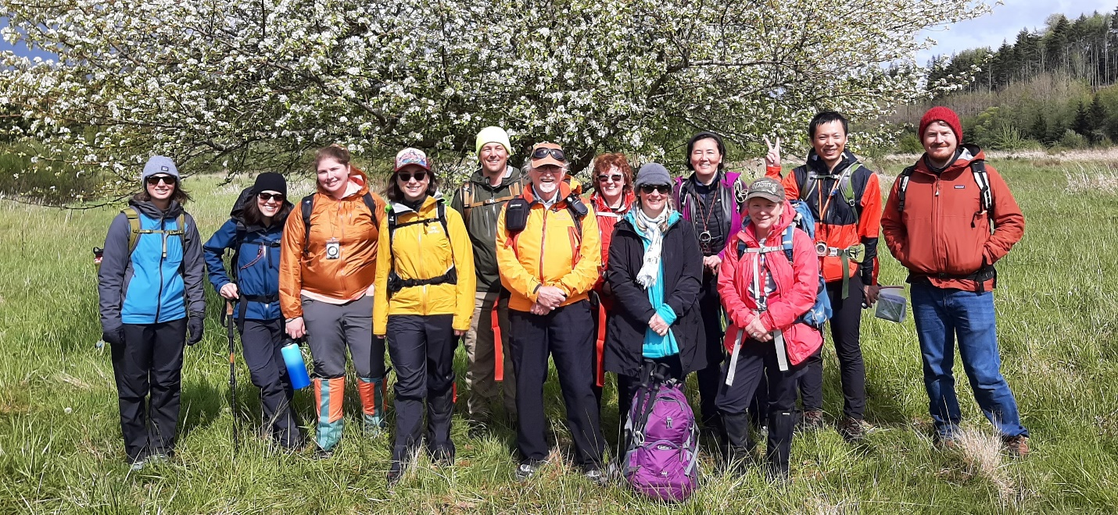

Compass Requirements
This course requires a high-quality compass, purchased before the first online class. Your compass MUST have the following features:
- Adjustable declination. Some compasses are sold with “declination scale” which is NOT adjustable declination. If you can’t adjust for declination, don’t buy the compass.
- Degrees in 2-degree increments and marked from 0 to 360°. You’ll need the accuracy of the 2-degree increments. Some compasses, called “quadrant,” are marked 0-90° four times around the dial. Do not buy a “quadrant” or “quad” compass.
- A transparent, rectangular base plate. You’ll need the transparency and the straight edges for plotting bearings on the map.
- Meridian lines. These lines are marked on the bottom of the rotating housing and rotate with the housing. These lines are how you use the compass with a map.
Additional, useful features include:
- A sighting mirror. Nothing improves the accuracy of your compass work like having a mirror.
- Large baseplate. Three to four inches is normal. Less than that is less useful for straightedge work on the map.
- Ruler and/or gradient scale. Usually engraved on the baseplate edge.
- Clinometer. This hanging arrow allows you to estimate slope angle and calculate heights (with a little geometry).
- Luminous points. This is handy in the dark or dim.

Acceptable Models
Expect to spend around $70. You do not need a “global” compass for this class – these cost more – though you may need one if you plan to use it for navigation in the southern hemisphere. Many are available from local retailers. Not all salespeople are knowledgeable about compasses and may try to sell you a compass that you won’t be able to use.
The following models meet the requirements above.
- Silva Ranger 2.0 (https://silva-usa.com/products/compass/ntn18826-silva-ranger-20-compass.html)
- Suunto Navigator MC-2 (https://www.suunto.com/en-us/Products/Compasses/Suunto-MC-21/Suunto-MC-2-Mirror-NH-Compass/)
- K&R Alpin (https://www.thecompassstore.com/alpin.html)
- K&R Sherpa BW2 (https://www.thecompassstore.com/sherpabw2.html)
- Brunton Truarc 15 (https://www.brunton.com/collections/instruments-compasses/products/truarc-15) The “tool-free” declination adjustment on Brunton compasses can be difficult to operate.
The following retailers may be able sell you the recommended compasses:
- Recreational Equipment (http://www.rei.com/)
- The Compass Store (http://www.thecompassstore.com/)

