Website Tools for Leaders to Document Participant Performance on Activities and Look for Information on Members Seeking to Join a Future Activity

- Viewing the roster and changing participant roles or status for your activity
As a leader of a Mountaineers activity you have access to a roster page for each activity which is one of the most useful tools available to you for activity prep. On this page you can keep track of who has registered for your activity, add others to the roster, or to manually change the status of participants (for example, to change someone from Participant to Co-Leader, from Registered to Canceled or from Waitlisted to Registered). To open the roster page for an activity, first double-click on the activity listing under ‘My Activities’ (under your name at the far upper right of the website main page), then click on Roster on the yellow admin bar of the activity listing. See the example of the roster page for an activity below. You must be listed as a leader, co-leader or committee Admin to be allowed to see this page for an activity.

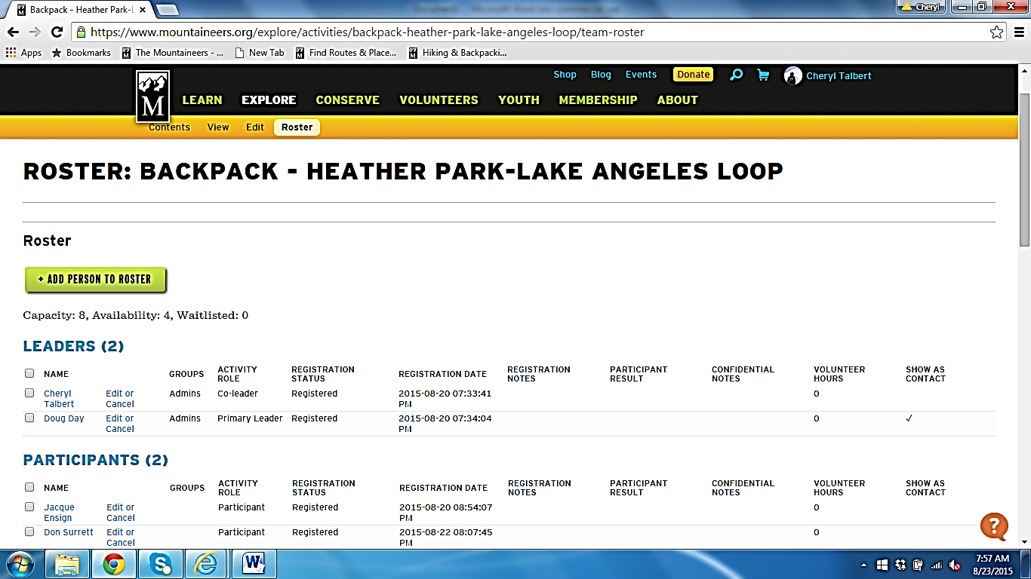

To change the Activity Role or Registration Status of a participant on your roster, click on ‘Edit or Cancel’ next to the name of a participant, and a screen will come up with several blocks of information and drop-down boxes for changing various aspects of the person’s status. The first example below shows your options for changing a participant’s Activity Role:
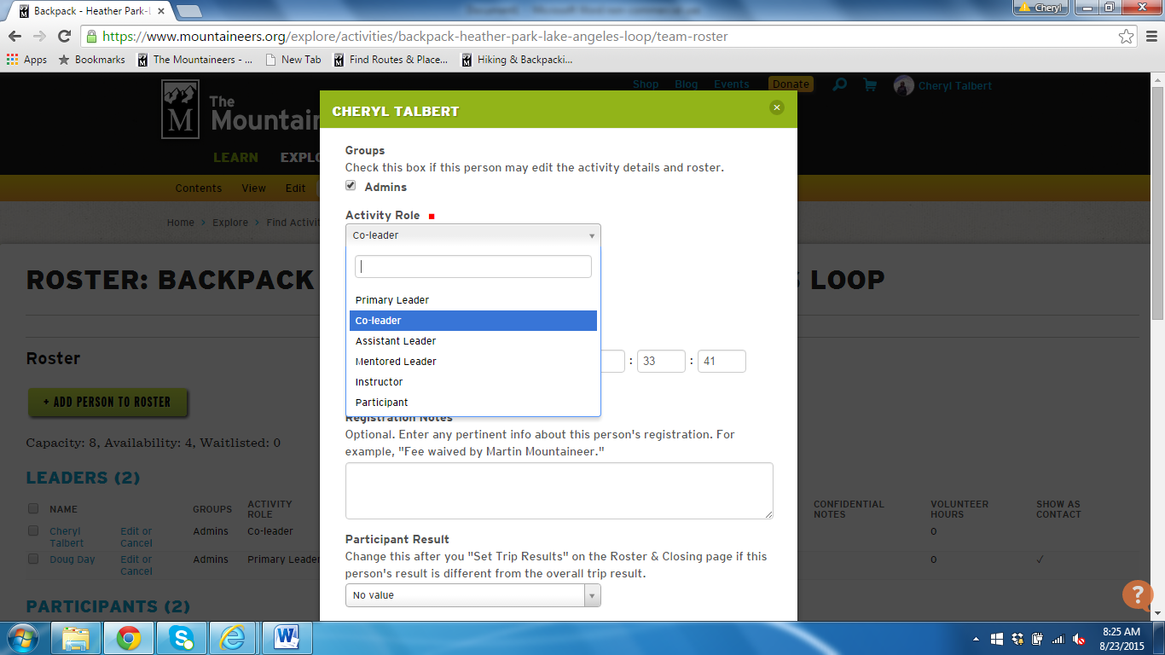

The next example below shows your options to change a participant’s Registration Status:

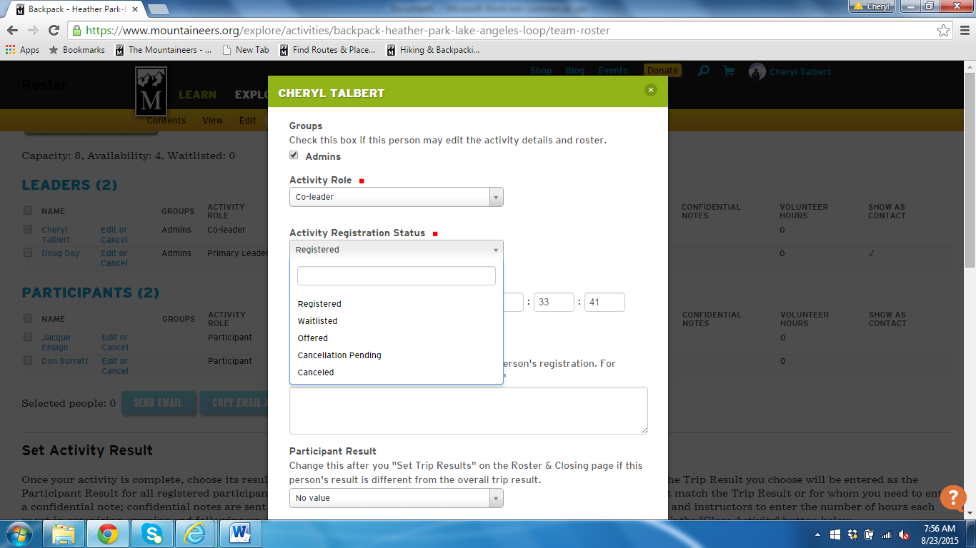

- Setting the Activity Result
After an activity has been completed, leaders are asked to set an overall activity result, record any participant performance notes, report any safety incidents, and close their activity. This should be done within a week of the completion of the activity. To set the overall activity result, open the roster, and without clicking on any participants, just scroll down the page to Set Activity Result and Trip Results, then select the option in the drop-down box that best describes the overall outcome of the activity, and then SAVE. Remember that is not a ‘failure’ to turn around if it would be unsafe or unenjoyable for the group to continue to the established destination, and you need not report ‘turned around’ even if the group chose a to change their endpoint or route during the trip due to a hazard or participant issue if the outcome was a similar activity. “Turned around” is meant to signal to a future leader that the planned activity was aborted and the resulting activity was not at all similar to what was posted in length or difficulty.
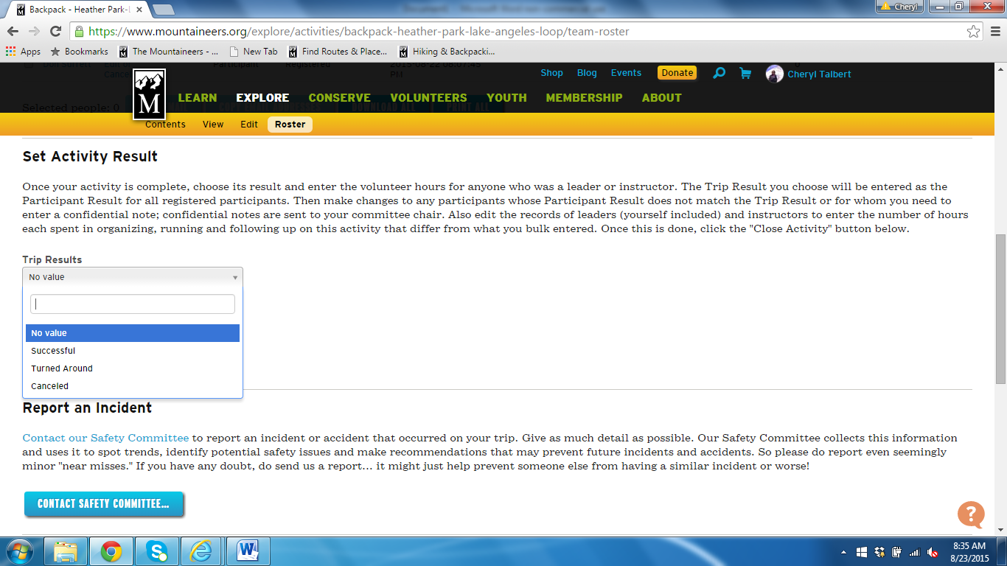

- Documenting participant performance issues for reference by future activity leaders

The roster page also affords an essential mechanism for leaders to communicate among one another about the performance of activity participants. To note an outcome or issue for a particular participant that is different from the overall activity result, first set the overall Trip Result and SAVE. Then scroll back up to the list of names on the roster, and click on ‘Edit or Cancel’ next to a participant’s name. Scroll down past the Activity Role and Registration Status blocks until you come to ‘Participant Result’. The following options are available to you to record how a person did on your activity:

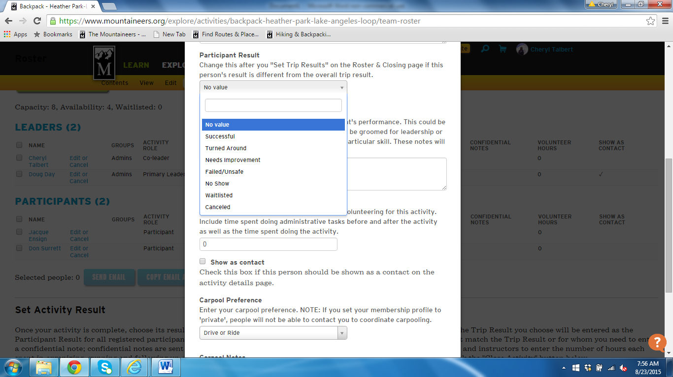
The default selection will be the outcome that you reported on the overall Trip Result, or ‘Waitlisted’ or ‘Canceled’ if the individual didn’t make it to the main activity roster. Three other critical choices are available to you that could be very helpful to a future activity leader trying to evaluate a person’s capability for another activity:
Needs Improvement: This selection could apply if an individual arrived with the wrong or insufficient gear, was not conditioned or otherwise physically capable of completing the itinerary as described, or behaved in an inappropriate manner on the activity (say, unsafe, rude or inappropriate behavior, bad trail etiquette or Leave No Trace practices, etc.). When such situations occur, it is also very important for the leader to offer respectful and caring but direct feedback and suggestions to the participant about what you observed, why it was a problem, and how they might improve in the future. Such conversations should be confidential and should take place either at the end of the activity or as soon as possible thereafter.
Failed/Unsafe: This is a participant result that should only be used if the person was so unprepared or incapable, or if their behavior was so inappropriate or unsafe to themselves or others, that they truly could not complete the trip or caused the entire group to abort.
No Show: This is a very useful note because it can indicate a pattern of behavior that future leaders need to be on the lookout for. A ‘no-show’ rating applies if the individual truly just didn’t show up at the agreed-upon meeting place and didn’t tell anyone; but it also applies if the individual calls to cancel while the group is en-route to the meeting place or even cancels on the day before the trip goes, when it is too late for other participants to modify carpooling plans or for waitlisted people to make arrangements to come on the trip.
Particularly if you mark someone as ‘Needs Improvement’ or ‘Failed/Unsafe’, it is a good idea for you to document the facts around the situation of concern and store it in a file where you can find it later. That way, you can access the factual details if another leader contacts you at a future date to ask for more information about the rating, or if a participant challenges you on your rating.
Be aware that such judgments can be hurtful and traumatic to a person, and we want Mountaineers experiences to be positive for everyone. Don’t make snap judgments, use positive, caring and constructive language, and make every effort to help the person improve. Before making a judgment about someone, step back and check whether your activity description and pre-trip communications were clear enough about the gear requirements, the physical requirements of the trip, and other major expectations. Even the expectation not to cancel at the last minute or to call if they can’t make it at the last minute may not be understood the same by everyone in the current Meetup culture, and needs to be spelled out in pre-trip communications.
Still, while you need to be careful about how you communicate performance feedback, it is very valuable to the individual and to future leaders and groups to note significant performance issues such as someone who comes to a hike completely unable to handle the physical demands, who behaves in a seriously unsafe or inappropriate manner, arrives completely lacking in necessary gear, or who is a no-show or last minute cancellation. A single unprepared individual can derail an activity and spoil the experience of everyone else in the group. The lack of ability to identify people lacking sufficient capability before a trip is one of the most commonly noted frustrations of trip leaders. If a person was a problem for your group, they could be a problem for a future group. Coach the individual, and share the information in the Participant Performance rating.
If there are truly significant issues with a particular individual, it helps for leaders to document such issues to their sponsoring committees in the Confidential Participant Notes for follow-up (Confidential Participant Notes are not visible to other leaders on the participant’s profile or activity history).
Once you have entered the Trip Result, modified individual participant performance as appropriate, and entered any confidential notes or safety incident information, then move to the bottom of the roster and select ‘Close the Activity’. After you close an activity you cannot go back and change anything.

- Documenting participant performance issues for reference by future activity leaders
Once you have entered a participant result, that information will show on that person’s Activity History, and future activity leaders will be able to search that history to get an idea of the activities that the person has completed as well as any performance issues they might have experienced. This is an invaluable source of information for future leaders.
If you are an activity leader evaluating the capability and experience of a person requesting to join one of your activities, you can find that person’s activity history by clicking on the magnifying glass icon at the upper right of the Mountaineers website main page, and entering the person’s name, as shown in the example below:
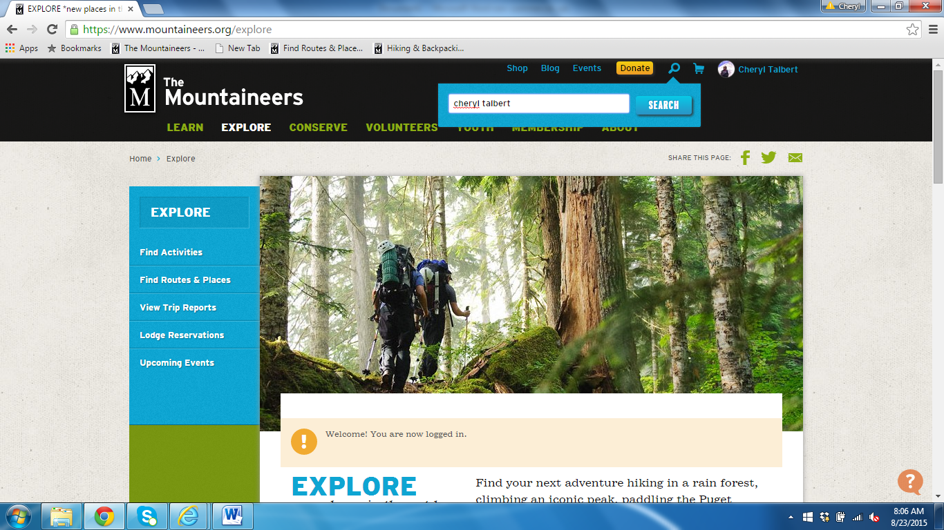

The following screen will come up – click on the person’s name in the red font as below:
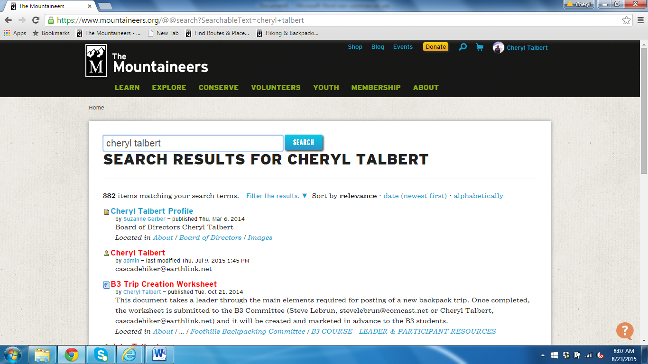
That person’s profile will come up, as below. Click on ‘My Activities’ in the left hand navigation bar (you can also click on ‘My Courses’ to see what courses they have taken and/or graduated from.
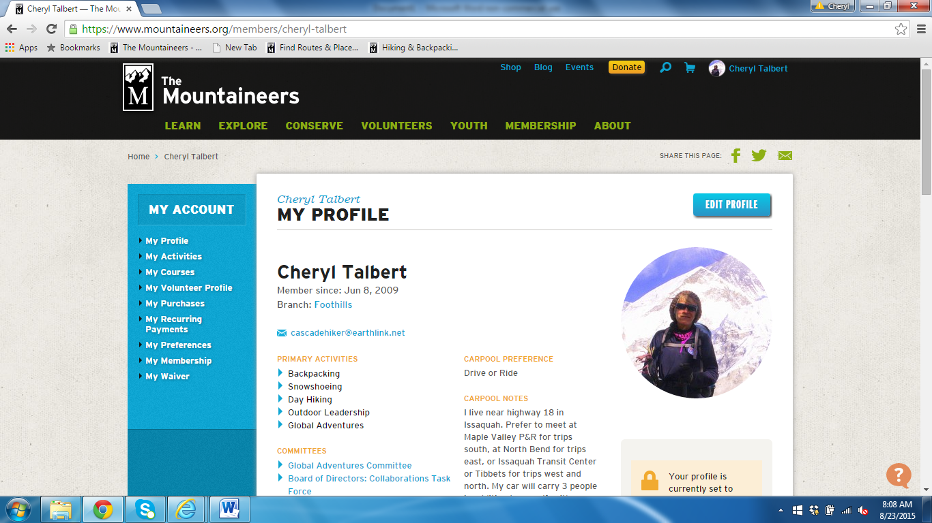

If you click on My Activities, the person’s future activities and their activities history will come up as below. Under Activities History, look to the far right under RESULT and you will see the outcome of each activity – Cancelled, Wait-listed, Successful, Turned around, Needs Improvement, Failed/Unsafe, or No Show. For more information about those ratings, you can click on the activity title to open that activity, find out what was involved, and get contact information for the leader for more information. You can scan down multiple years of their Mountaineers activities to look for patterns of issues.

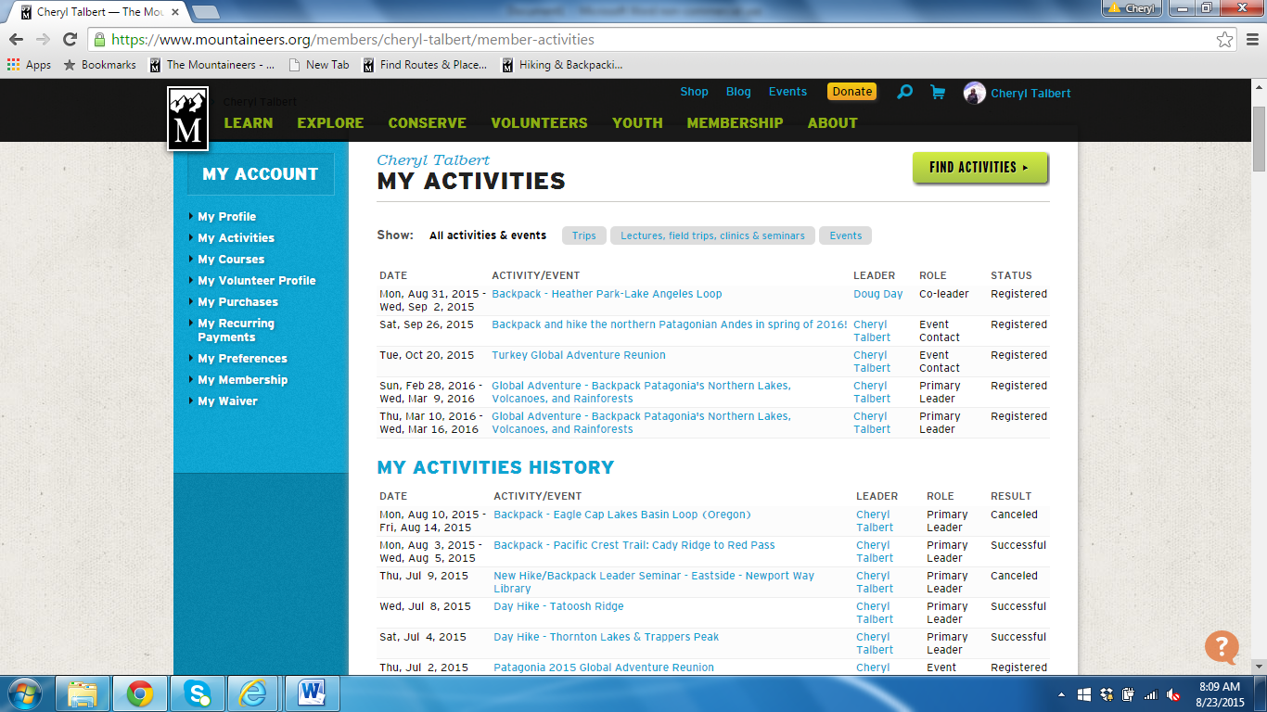
While leaders are encouraged to make use of members’ activities history and performance ratings to provide an initial indication of a person’s capability to complete a future activity safely, people can have bad days and their fitness can change dramatically with time. Not all of their activities will necessarily be with the Mountaineers so they may have a lot more experience than their activities history shows. So do not jump to conclusions about somebody’s fitness for your planned activity based on a set of performance ratings. Before turning someone down for your activity, call or send an email to the leaders of their most recent activities to find out more about the person. Give the person him/herself the opportunity to tell you about their fitness and help you understand what happened in a past activity where they had trouble. Always remember that the Mountaineers mission is to get people into the outdoors and give them a set of skills and experiences that they enjoy and treasure. A person could quickly be hurt and turned off by someone who makes a judgment about them based on incomplete information. Be considerate and caring. If you do deny someone permission for your activity, do it based on facts and explain your reasoning. Be ready to suggest an alternative activity for the person that better suits their capabilities.

For more information and instructional videos on using the Mountaineers website tools, go to https://www.mountaineers.org/volunteers/schedule-an-activity.

Participants can also cancel themselves, which will automatically show as a status change on your roster page, and as individuals cancel, the first person on the waitlist will automatically move up onto the roster.

