not a member? join now! view as a web page


Happy June, Foothills Mountaineers!

Summer has finally arrived in the PNW and I’m sure you’re eager to get outside and have some fun! Check out all these fun Foothills Branch activities to get outdoors and enjoy this beautiful season.

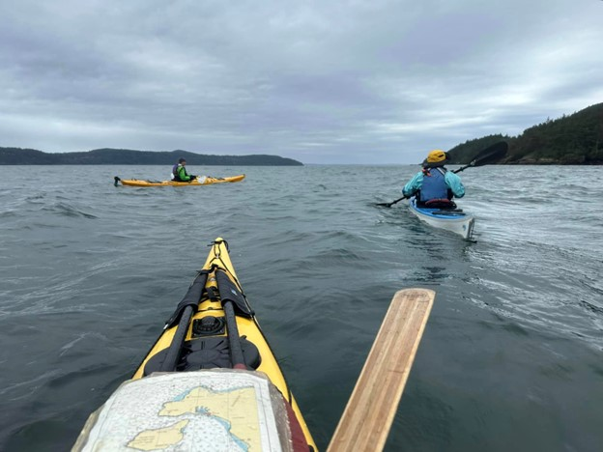

Practicing ferry crossings in current under the protection of the lee of Burrows Island. Photo by Doug Palm.

Events

Walking the Wild: Trek the Tour of the Jungfrau | Jun 12
Join Cheryl Talbert as she shares tales of her 12-day, 100-mile trek in Switzerland over several high passes (including the highest trekking pass in the Bernese Oberland, the Hohturli) and through some of the most glorious alpine landscapes the world has to offer.
2024 50-Year Member Luncheon | Jun 13
Join us for a reception and hosted lunch to celebrate Mountaineers who have 50+ years of membership and have reached lifetime member status.
Trail Running Weekend | Aug 9-11
Join the Foothills Trail Running Committee for their second annual Trail Running Weekend at Baker Lodge with great food, new and old friends, and a few more miles on your shoes as you explore scenic trails through the Mount Baker Wilderness. Whether you’re an experienced runner or just starting, this weekend is sure to leave you feeling invigorated and inspired.
Pasayten Cabin Volunteer Vacation | Sep 12-18
Spend a week with the Washington Trails Association (WTA) as they re-open the Boundary Trail for their Lost Trails Found campaign to put backcountry trails back on the map. This stunning trail passes through the remarkable terrain of the North Cascades. The adventure includes a 14-mile hike to camp from Harts Pass, down 3,000 feet into the Middle Fork of the Pasayten River.

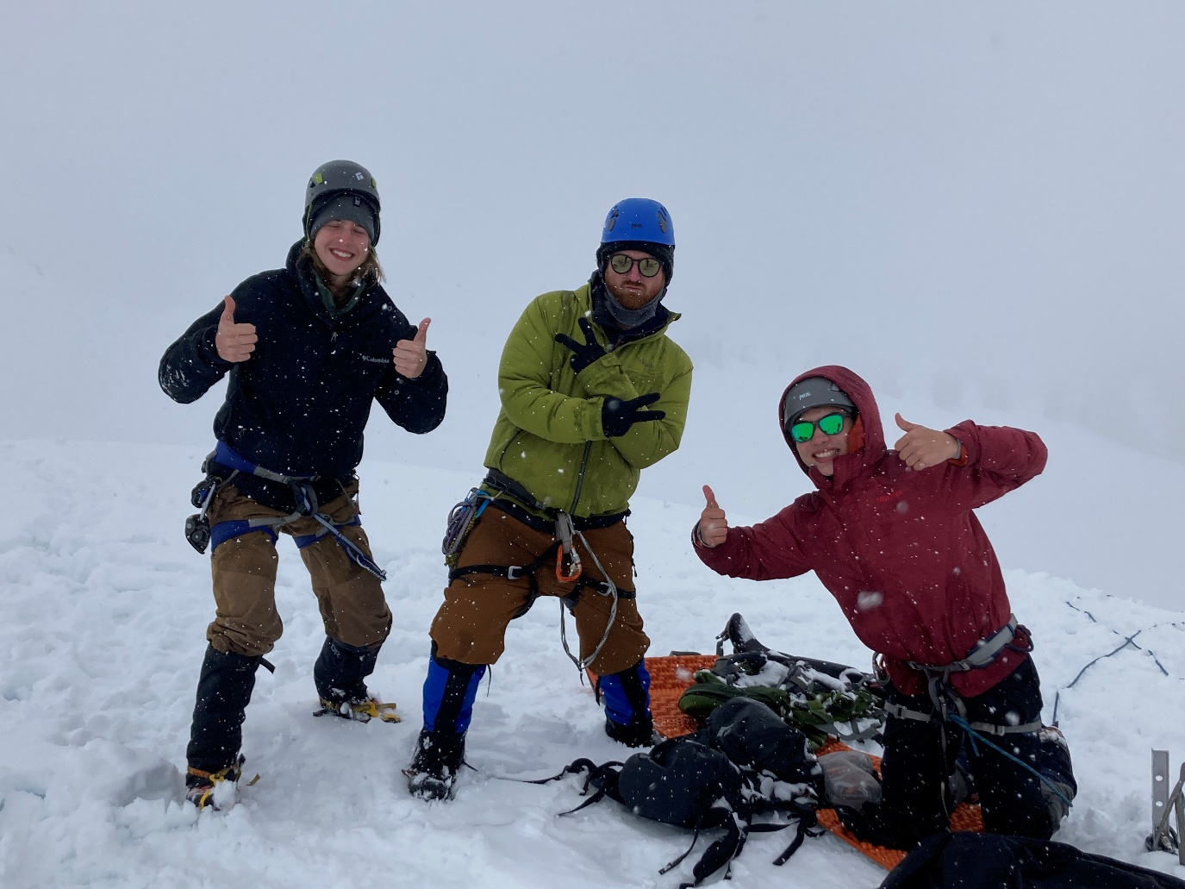

Mountaineers enjoying the snow at Baker. Photo by Mountaineers staff.

Courses & Seminars

New Hike-Urban Walk-Backpack Leader Seminar | Jun 11
This online seminar provides experienced Mountaineers hikers, urban walkers, and backpackers information they need to become an effective leader for The Mountaineers. This seminar is one of the pre-requisites to becoming an official Mountaineers hike or backpack leader.
Yoga for Mountaineers | Jun 13
This outdoor yoga class at Lake Sammamish State Park is all about finding balance: balance of the body in space; balance within the body, front to back, top to bottom, side to side; and balance between work and rest. Everyone is welcome, regardless of fitness level or yoga experience.
Leadership Challenges Discussion & Workshop | Jun 19
This seminar is for Foothills hike, urban walk, and backpack leaders interested in discussing leadership challenges with their peers. It includes a practical application workshop focused on trip posting essentials and pre-trip communications.

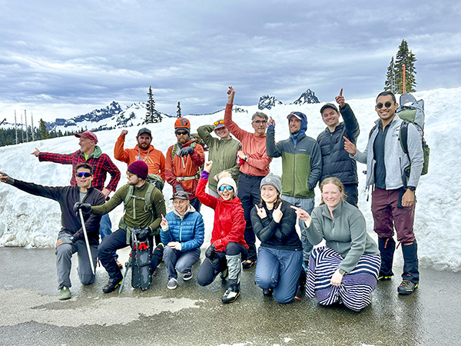

GoHike participants performing trail work at Northern State Recreation Area.

Activities

Urban Walk - Sammamish River Trail | Jun 16
This urban walk will begin at Bothell Landing Park and head northeast on the scenic Sammamish River Trail to Woodinville's Wilmot Gateway Park.
Frontcountry Trail Run Discovery Park | Jun 17
Start your Monday off on the right foot with this early morning, dog-friendly run.
Stewardship at Northern State Ghost Town | Jun 22
Join the Skagit Trail Builders at the Northern State Recreation Area for a day of trail work on a new trail.

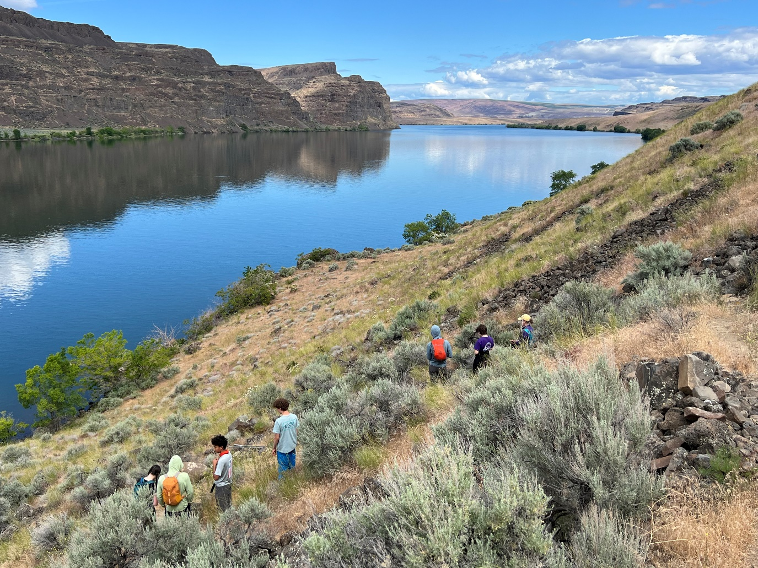

Mountaineers youth backpacking Ancient Lakes. Photo by Mountaineers staff.

News & Notes

It’s tick season. Learn how to defend yourself with these tips on hiking in tick country from the Washington Trails Association.
Safe glissading. Glissading can be fun, but it also comes with its own set of hazards. Learn how to glissade safely.
Nominations Open for Board and Branch Leadership
Each year, The Mountaineers host a public nominations call for passionate individuals to join the Board of Directors and branch leadership. Nominate yourself or someone you know by June 21, 2024 to help drive the future of our organization.
The Mentored Backpack Leaders’ Course is a new offering for the Foothills Community this year. Learn more about the course from course leader, Rob Erickson.

Get to Know Danielle Graham, Foothills Safety Officer
In our newsletter, we introduce you to Foothills Branch Council members or activity committee chairs who make our Foothills Branch thrive. This month, meet Foothills Safety Officer, Danielle Graham.

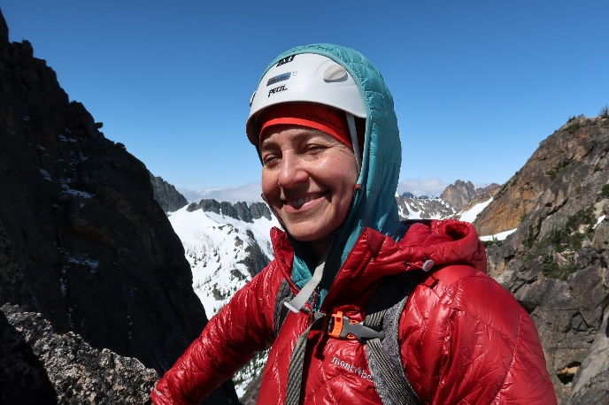

Meet Danielle

More Seattle-area therapists are taking their sessions outdoors. Learn more about the work Foothills Hike Leader Becky Robbins is doing with nature therapy.
Volunteer Spotlight: Chris Ensor
Meet Chris Ensor, a Foothills Hike, Urban Walk, and Cross-Country Ski Leader and 2023 Super Volunteer. Chris has earned Key Leader and Super Volunteer badges every year since 2014. He earned the Foothills Branch Service Award in 2020.

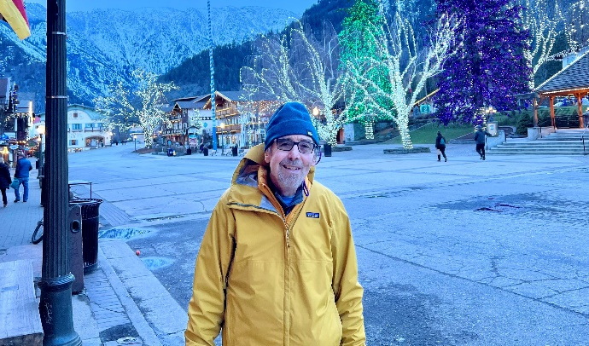

Meet Chris


www.mountaineers.org
The Mountaineers enriches the community by helping people explore, conserve, learn about, and enjoy the lands and waters of the Pacific Northwest and beyond.
Unsubscribe | Update Preferences

This email was sent to lorieheath@live.com
The Mountaineers, 7700 Sand Point Way, Seattle, WA 98115-3996, US
Read our Privacy Policy

