not a member? join now! view as a web page


Happy August, Foothills Mountaineers!

I hope you’ve been enjoying this beautiful summer and finding plenty of opportunities to get outside and have fun! Summer is usually a busy time of year for outdoor enthusiasts, so don't wait to check out our upcoming branch activities to help you enjoy the outdoors this season.

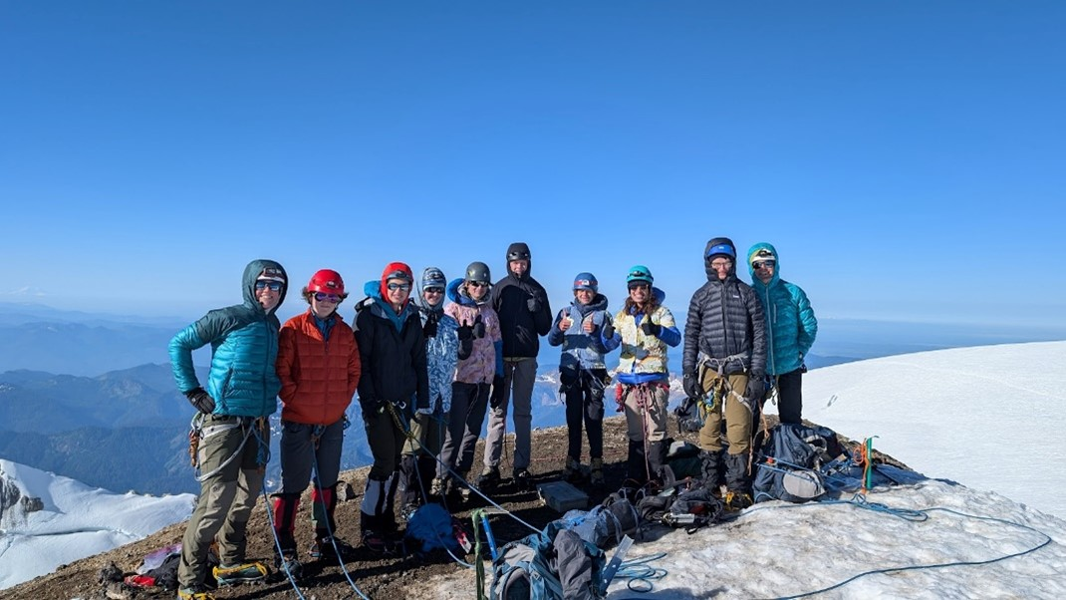

Photo by Kevin Defields.

Events & Activities

Frontcountry Trail Run - Discovery Park | Aug 12
Make Monday less unpleasant with an easy, early morning, dog-friendly run.
Yoga for Mountaineers - Lake Sammamish State Park | Aug 14
Let the physical and mental benefits of outdoor yoga help you develop strength, balance, and awareness to enrich your outdoor activities. This outdoor yoga class features long holds in poses that target major muscles groups (including the core) to help you develop strength for your next challenge.
Get-Together for Women/Non-binary Scramblers and Climbers | Aug 28
Join for a social get-together of experienced and aspiring women and non-binary scramblers and climbers. Share stories and experiences, make new friends, and learn about ways to get involved with Foothills scrambling and climbing.
Stewardship - Shadow Lake | Aug 31
Help beautify the 120-acre preserve and wetland bog at Shadow Lake by maintaining trails, removing invasive weeds, and planting and pruning native species.
Pasayten Cabin Volunteer Vacation | Sep 12-18
Spend a week with the Washington Trails Association (WTA) as they re-open the Boundary Trail for their Lost Trails Found campaign to put backcountry trails back on the map. This stunning trail passes through the remarkable terrain of the North Cascades. The adventure includes a 14-mile hike to camp from Harts Pass, down 3,000 feet into the Middle Fork of the Pasayten River.
Freedom10 Kickoff Party | Sep 23
Join us at the Seattle REI Co-op for a kickoff party to celebrate the launch of the 10th edition of Freedom of the Hills.
Foothills 2024 Scramble Celebration | Sep 25
Get together to celebrate Foothills Scrambling graduates, leaders, mentors, officers, and volunteers.
Urban Walk - Centennial Trail | Sep 28
Enjoy an all-day walk on paved Centennial Trail from Snohomish to Lake Stevens and back.

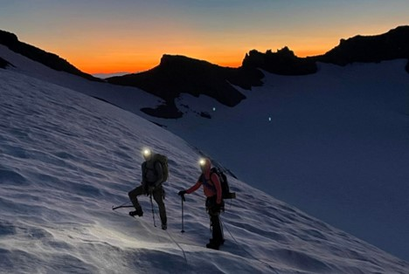

Nick de Steiguer and Larry Zimmer up early for an alpine start on Little Tahoma. Photo by Ian Lauder.

Courses, Clinics, & Seminars

Wilderness Navigation | Starts Aug 31
This course focuses on "off-trail" navigation requirements for climbing, scrambling, intermediate snowshoeing, and other more advanced courses.
Urban Walk Leader Pedestrian Safety Seminar | Sep 4
This online seminar is for hike leaders who are interested in leading Urban Walks and earning the Pedestrian Safety Skills badge and/or an Urban Walk Leader badge, as well as individuals interested in learning about pedestrian safety and/or earning the Pedestrian Safety Kills badge. The session will focus on preparing leaders to lead Urban Walks that anticipate and manage risks and opportunities unique to urban and suburban settings.
Sound Bath and Urban Walk-Magnuson Park | Sep 7
Bring your yoga mats for a meditative experience with a sound bath session by Sound Alchemy at The Mountaineers Seattle Program Center, followed by a 2-3-mile urban walk around Magnuson Park.

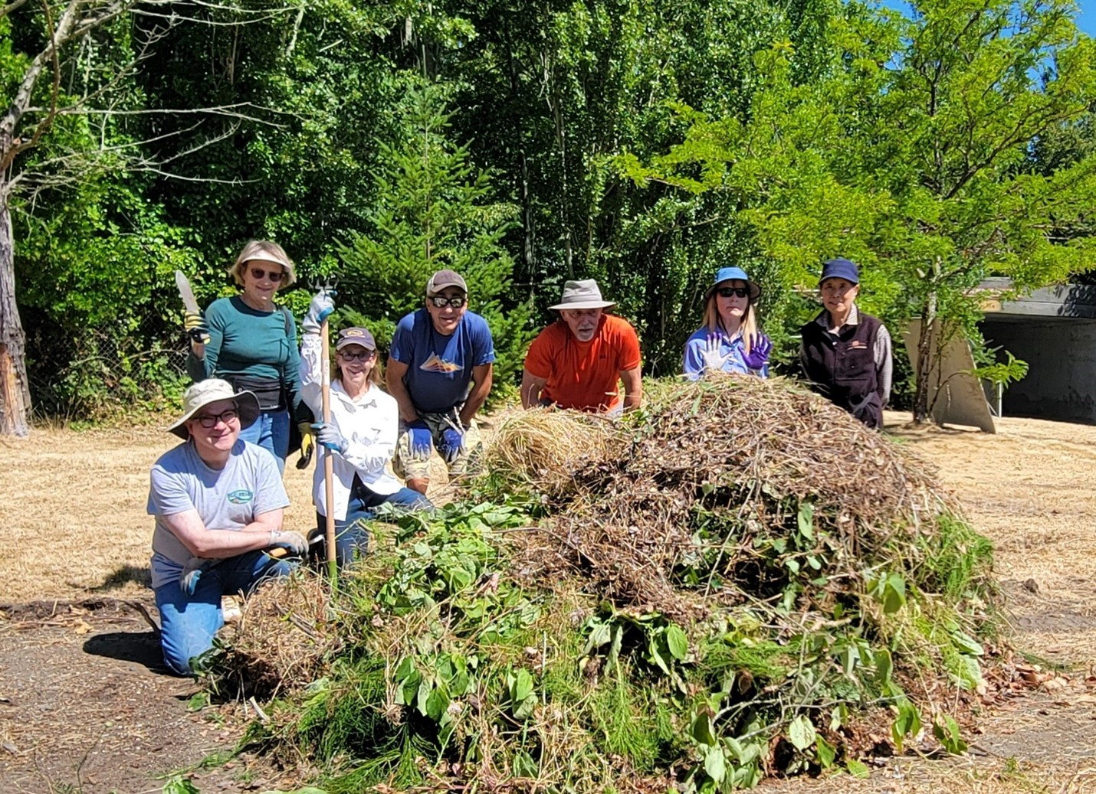

A group of stewardship volunteers hard at work beautifying The Mountaineers Seattle Program Center. Photo courtesy of Elizabeth Nakashima.

News & Notes

Foothills Branch Service Award
Nominations are now open for the 2024 Foothills Branch Service award! Is there a Foothills leader who has inspired you to enjoy the outdoors? Nominate them by Aug 31, 2024 for the 2024 Foothills Branch Service award.
2024 Open Elections
Elections for the Board and branch leadership are approaching! Elections will open for voting to members on September 1 and run through September 22. The Foothills Branch will vote on the following positions:
- Foothills Branch Treasurer, serving a two-year term.
- Foothills Chair-Elect, serving a one-year term as chair-elect then two-years as chair.
- Branch Representative to the Board, serving a one-year term.
Look for an election email in your inbox on September 1 for more details about the roles and candidates.
Safety Updates
The Mountaineers is committed to keeping our community safe, both physically and emotionally. Learn more about what we’re doing to foster safety and prevent sexual harassment and sexual assault and find out more about the new Sexual Harassment and Sexual Assault Prevention (SHSAP) Committee.
In June, a group of 20 members from Seattle and Foothills Branches met to discuss emotional safety at The Mountaineers. Read the recap blog, summarizing their workshop and recommended best practices.
Foothills Backpacking Committee Update
The Foothills Backpacking Committee is pleased to welcome new backpack leaders: Andrea Shadrach and Jennifer Wang. Thanks to Becca Watson and Lorelei Felchlin for their mentorship.
Foothills Urban Walk Committee Update
The Urban Walk Committee would like to welcome their newest leaders: Mary Ann Baltich, Christina Buckman, Becky Robbins, and Bianca Szyperski. Thanks to Pam Jorgensen, Kelley Chaddock, Rob Erickson, and Valerie Ensor for mentoring the new leaders.
Conservation & Advocacy Update
The Mountaineers Conservation & Advocacy Committee is excited to share the newest version of The Mountaineers Advocacy Agenda. Take a look to learn what The Mountaineers advocates for and what we prioritize.
The Foothills Conservation Committee recently formed a stewardship partnership with The Mountaineers Seattle Program Center (SPC). Before the partnership, a staff member maintained the SPC outdoor property. The new partnership will provide additional resources to enhance and maintain the facility, as well as additional stewardship opportunities. At the first joint activity, an amazing group of volunteers spent the morning weeding, pruning, and clearing the front area of the property. Keep an eye out for upcoming opportunities to support the home of The Mountaineers!
Trail Ambassadors
For a third consecutive summer, The Mountaineers is partnering with Washington Trails Association (WTA), US Forest Service (USFS), and Glacier Peak Institute to sponsor the Trail Ambassadors along the Mountain Loop Highway. Trail Ambassador volunteers welcome hikers at popular trail heads, such as Mount Pilchuck and Heather Lake. They educate hikers on topics such as Low Impact Recreation, The Ten Essentials, trail etiquette, and how to recreate outdoors safely and responsibly. The Foothills Branch will be leading Trail Ambassador volunteer events through Labor Day. Those interested in volunteering as a Trail Ambassador should contact Linda Martindell for more information.

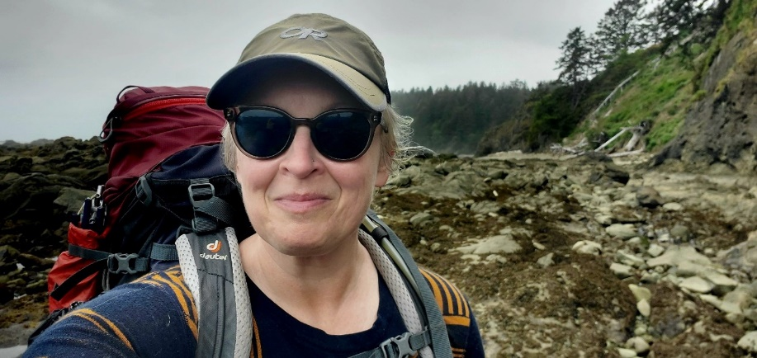

Leader Feature: Christina Buckman

In our newsletter, we introduce you to Foothills Branch Council members or activity committee chairs who make our Foothills Branch thrive. This month, meet Foothills Backpacking Committee Chair, Christina Buckman.
Christina is the Foothills Backpacking Chair as of January 2024. She approaches this role with three main pillars of focus: mentorship, leader engagement, and advocacy. Christina has been involved with The Mountaineers since 2018. She began as a student in the Backpacking Building Blocks (B3) course and was inspired to be a leader and mentor. Christina is also the co-creator and administrator for the Foothills GoHike course that launched in 2021. She is immensely proud of GoHike’s continued success and meaningful impact. Christina’s skills as a human resources professional help her advocate for leaders, foster connections, and build community. In her term as Backpacking Committee Chair, Christina will focus on leader engagement, removing barriers to leadership, and fostering a welcoming and inclusive backpacking community. Christina is a born-and-raised Washingtonian who - when not on the trails - enjoys watercolor painting, taking care of her 25 house plants, going to concerts, and spending time with friends and family.

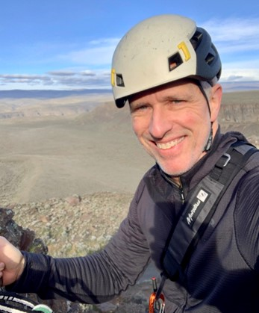

Volunteer Spotlight: Stephen Johnson

Meet Stephen Johnson, a Foothills Scramble, Climb, and Hike Leader. Stephen has earned Super Volunteer badges every year since 2020. He earned Key Leader and Key Instructor badges in 2023. Stephen instructs scrambling and climbing courses and enjoys providing mentorship and guidance to new scramble leaders.
What brought you to the Pacific Northwest and when did you come?
My partner and I relocated from Southern California 11 years ago and are happy to now call the PNW home!
What attracted you to The Mountaineers?
A few years ago - when I was still only a day hiker - I went up Mt. Si Main Trail for the first time, looked at the steep Haystack scramble, and thought: "Um… no. I really want to get up there, but I don't have the skills or confidence." I figured there had to be a class that teaches you how to do whatever that was. I went home and Googled "steep hiking class Seattle" and the first thing that came up was The Mountaineers. I went to a Meet the Mountaineers info session, learned what the word "scrambling" meant, signed up for a course, and the rest is history. Since then, I've seen over and over how The Mountaineers plays such an important role in the process of "I can't do it now. What would it take to do it? I did it!"
What have been your favorite volunteer memories with The Mountaineers?
Each season, I try to lead a sunset Guye Peak scramble, and last year my assistant and I were able to help a participant - very accomplished in their career field - deal with a fear of exposure on summits. With some support and coaching, she put her hand on top of the summit rock and was just elated. The sun was setting behind the Tooth right as our group summited. These moments make all the volunteering worthwhile.
What are your favorite activities and/or places in the PNW?
After instructing for much of the winter and spring, I like to recharge with alone time on solo scrambles to more remote destinations later in the season. Lately, I've been loving the Methow Valley - a long but amazing drive and a different topography and vibe.


www.mountaineers.org
The Mountaineers enriches the community by helping people explore, conserve, learn about, and enjoy the lands and waters of the Pacific Northwest and beyond.
Unsubscribe | Update Preferences

This email was sent to lorieheath@live.com
The Mountaineers, 7700 Sand Point Way, Seattle, WA 98115-3996, US
Read our Privacy Policy

