Map and directions to Kahler Glen
20890 Kahler Dr., Leavenworth, WA 98826

North of Leavenworth. Hwy 2 west to State Route 207 for 3.5 miles. Turn left on Cedar Brae Road to Lake Wenatchee State Park South Park entrance. Turn left at entrance but do not enter park. Travel a half mile for another left turn until the road forks. Stay on the left fork to Kahler Glen Golf Course. Sno-Park is at entrance.
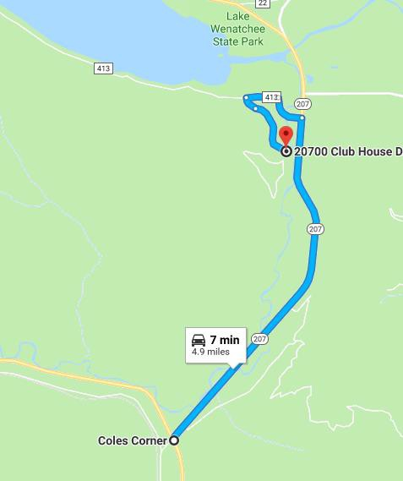
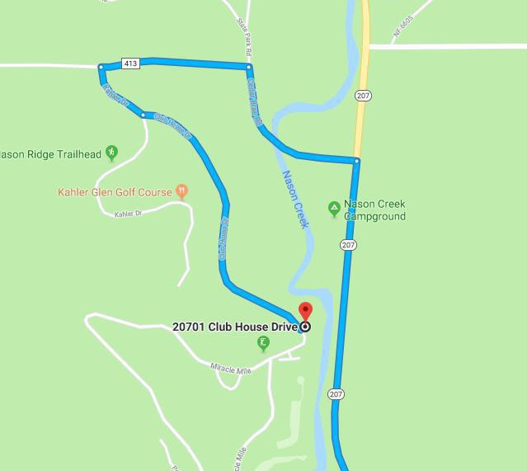

Map and directions to Stevens Pass Nordic Center
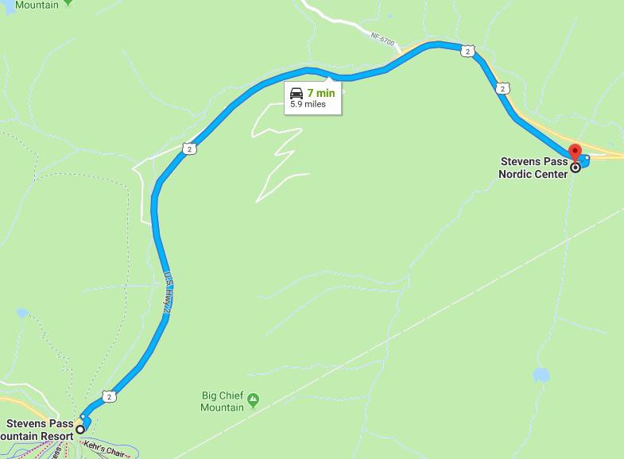
  - miles east of the Stevens Pass Ski Area. Entrance will be on the right.

Map and directions to Crystal Springs/Erling Stordahl Snopark
- miles east of Snoqualmie. Take exit 62 for Crystal Springs. Turn right. Park in the first section on the left.

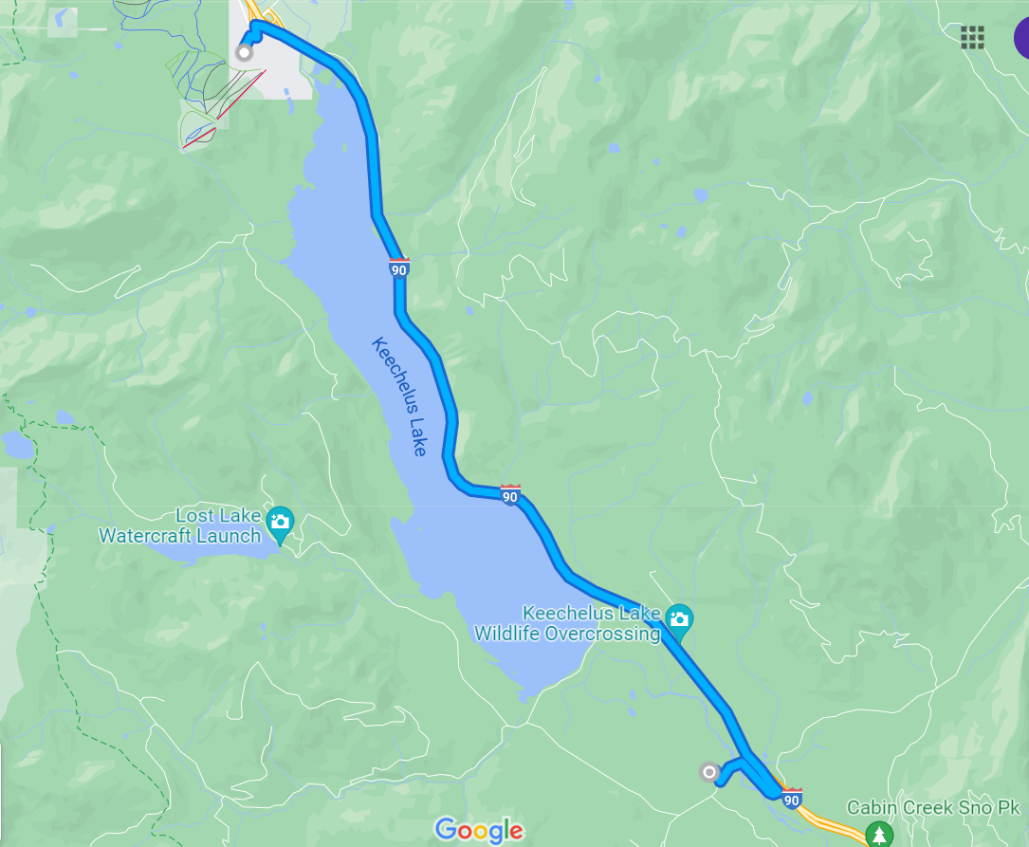

Map and directions to Gold Creek Sno-Park:
Drive east on I-90 over Snoqualmie Pass to exit 54, 2 miles east of the pass's summit. Exit I-90, turn left, cross under the freeway, and just a few hundred feet north of the highway interchange, turn right onto a narrow-paved road and drive east parallel to the freeway for 1 mile.
