Trek Peru’s Ausungate Circuit and Rainbow Mountain, early June 2020
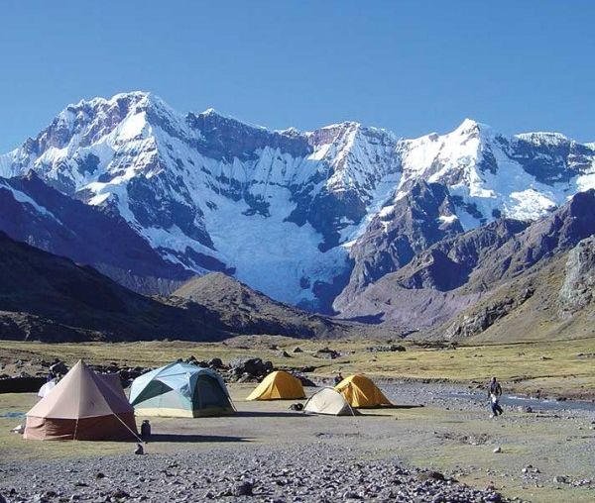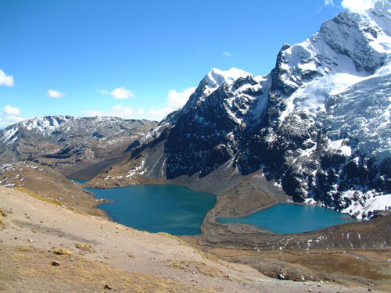
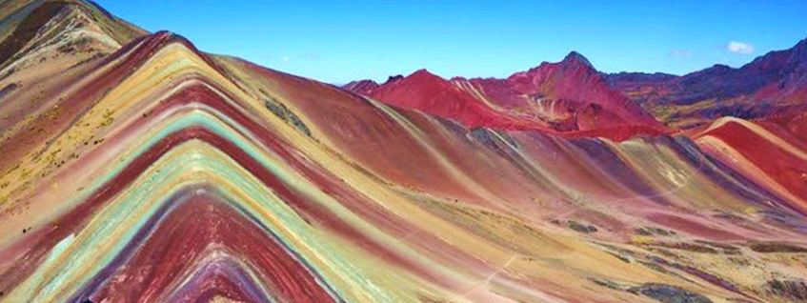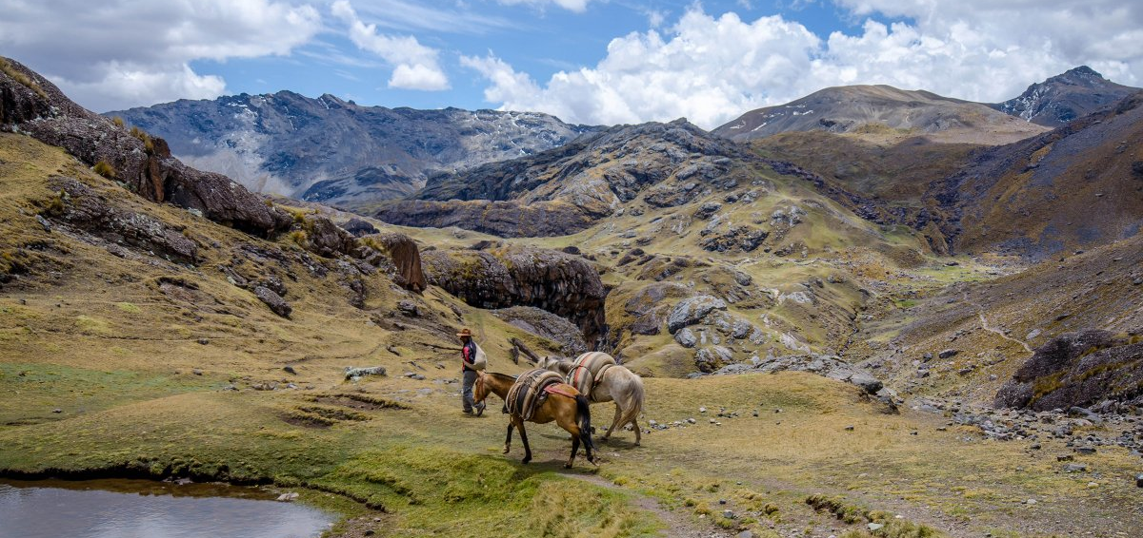
This supported trek will take participants into the remote, stunning landscapes of Peru’s ‘Sacred Mountain’ of Ausungate, including custom side trips to the pilgrimage site of Qoyllur Rit’I and the Vilcanota ‘Rainbow Mountain’ (not normally included with commercially available Ausungate circuit treks), with the colorful historical Andean city of Cusco as our gateway.
Participants will start with three days of acclimatization day-walks up to 13,500’ from our hotel in Cusco, including a walk past the Inca Ruins of Tambomachay, Puca Pucara, Q'enqo and Sacsayhuamanjust above the city; one to the Chacan cave (called the Temple of the Rainbow because of the small waterfall inside the cave that reflects rainbow rings off the sun’s rays), and the Temple of the Moon, a natural rock structure witha manmade altar on which the full moon shines at certain times of year; and a third to Huchuy Qosqo (Small Cusco), ruins that are believed to have been abandoned by the time the Spanish arrived in Peru and which offer spectacular views of the Sacred valley.
Then we’ll transfer 3.5 hours in private vans to the starting point of our Ausungate trek, Tinqui at 13,123’, along the way doing one more acclimatization dayhike to amazing views high on the peak of Pachatusan. We’ll spend two nights at Tinqui camp including a side trip to the sacred pre-historic shrine of Qoyllur Rit’I at 15,091’, returning to Tinqui for the night. Then we’ll set off on a 6-day trek around the sacred mountain of Ausungate. Partway around the circuit, we’ll diverge from the main trail to the Vilcanota ‘Rainbow Mountain’ to see its stunning ribbons of color. We’ll end the trek with a night at the natural hot springs at Pacchanta.
This is a high-altitude trek that remains above 13,000’ for 8 nights and crosses 3 passes over 16,000’ (highest at 17,060’ on the 5th day out from Tinqui). Trekking days have been kept mostly modest, under 8-hour days (shorter days when we have more altitude to gain during the day).
The group will be supported by Apus Peru, a local operator with a great reputation and years of experience leading this and many other treks in the Cusco area. Depending on the size of the group (min 8, max 12), we may have 1-3 guides, as well as porters and donkey drivers to carry our overnight gear, food and dining-cooking equipment. We will be carrying daypacks and camping every night.
We will stay in a nice three-star hotel in Cusco before and after the trek. Luggage will be stored at the hotel during our trek so that participants have their town gear when they get off the trail.
NOTE: While the route is well graded and marked, this is a very challenging trek that includes very cold temperatures and exposure to high altitude for several days. Though we will have multiple exit options during the route, exit (by horse) to a road and back to a medical facility is difficult and time consuming. Participants must be experienced with strenuous mountain trekking and have the gear to pack properly for very cold conditions. Medical history will be requested from all applicants and anyone who has a history of altitude illness above 14,000’or other medical conditions potentially exacerbated by cold or high altitude is cautioned against participating in this trip. Participants will be encouraged to take Diamox (with the approval of their doctor) to reduce the likelihood of altitude illness symptoms.
Access to Cusco is through Lima Peru. The trip dates in early June are in the heart of the driest season in the Peruvian Andes, though it is also moving into the coldest season.
Assistance can also be provided with booking of a private six-day Machu Picchu-Sacred Valley cultural tour after the main trek, with guides, Vistadome train transport and stays in nice hotels in Cusco, Ollantaytambo and Aguas Calientes provided by Apus Peru.
THE TRIP ORGANIZER: Cheryl Talbert has organized and led 3 group trekking trips in the Peruvian Andes, and several more in the Patagonian Andes, Nepal, the Alps, the Sierra Nevada and Rocky Mountains, and New Zealand. This is her first trip on the Ausungate route.
PRICING: The final price will be determined based on the number of travelers, but at present I estimate $2600pp including food and lodging in Cusco, private transport to and from the dayhikes and the trek, and guides, support staff and all food and camping equipment while on the trek. Those who want to spend additional days to visit Machu Picchu may spend an additional $600-1500, possibly a bit more depending on the itinerary.
