Global Adventure Proposal: Trek Hut to Hut on New Zealand’s “Great Walks” and Alpine Trails. Feb 9-26, 2027. Pre-trip extension on New Zealand’s North Island including the Tongariro Circuit Great Walk, Feb 1-9, 2027
Activity Description
- Summary: Our 18-day main itinerary, all on the South Island, (which includes 11 days of moderate to strenuous hut trekking) will start in the bustling adventure-hub of Queenstown transferring to the quiet lakeside town of Te Anau which will be our gateway for two of the best of the country’s ‘Great Walks’ – the Milford and Kepler tracks. Both of these feature a mix of New Zealand’s lush native forest filled with the sounds of native songbirds, lovely lakeside views, and stunning, view-rich alpine ridge walking, between basic but comfortable mountain huts. At the end of the Milford Track we will take a boat cruise up the Milford sound under innumerable waterfalls to the Tasman Sea, watching for seals, dolphins and penguins! After these two treks (and a rest day in Te Anau) we’ll venture southeast to the Otago Peninsula through its rolling golden hills and miles of wild coastline, to visit a Royal Albatross colony, a penguin sanctuary, and some beaches where penguins come ashore to nest on the bluffs, plus a chance to spy New Zealand fur seals, Hooker’s Sea Lions, and tiny Hector’s Dolphins. Then, driving westward along the scenic south coast, we’ll come to the little town of Tuatapere, gateway for the country’s newest Great Walk – the Hump Ridge Track, featuring lush tree fern forest, high alpine tussock with limestone spires and tarns, and beach walking along the Southern Ocean. After completing the Hump Ridge we’ll shuttle back to Queenstown for flights home. The trip will involve walking up to 12 moderate-to-strenuous miles and up to 3500 feet of gain/loss per day between backcountry huts with overnight packs (no tents or stoves but all other overnight gear and food), plus days to explore, do optional adventure activities, and enjoy fabulous food in the towns of Queenstown and Te Anau. Transportation will be primarily by self-driven rental vans.
- An optional 8-day excursion before the main itinerary will offer a chance to explore highlights of the North Island including the lovely Auckland harbor district, Rotorua with it’s colorful thermal areas and Maori culture, majestic Lake Taupo, and a memorable four-day trekking loop (31 miles, 6000 feet of total gain and loss) around a cluster of active volcanoes, volcanic dikes and surreal-colored lakes on the Tongariro Northern Circuit (carrying tents, food and overnight gear to camp along the way). We’ll also have the opportunity to explore the unforgettable limestone caves and underground rivers of Waitomo on our own with glow-worms overhead before we head back to Auckland for flights to Queenstown to join the Main Itinerary.
- NOTE: The Member fee of $1850 shown is for the 50% deposit and the 18-day Main Itinerary only; the total price is $3700. If you elect to also go on the 8-day North Island pre-trip extension, you will be asked to pay an additional $1300 at the time of booking to cover the total incremental extension cost. You must submit the application at the link found in the Registration Instructions below to be considered; Leader Permission requests are not sufficient.
- Itinerary Highlights: Our main 18-day itinerary, all on the country’s South Island, will consist of 11 days of trekking hut to hut on three of New Zealand’s “Great Walks” in the Southern Alps featuring lovely lakeside and coastal views, stunning, view-rich alpine ridge walking, and lush native forest filled with towering tree ferns and the sounds of native songbirds. Between the first two treks and the last one we’ll have a fun driving- and day-hiking journey across the plains and mountains from Te Anau to the Otago Peninsula and along the south coast where we’ll see and explore the stunning coastline and unique wildlife and birdlife, on our way to a third Great Walk that includes high alpine, southern ocean and tree fern forests.
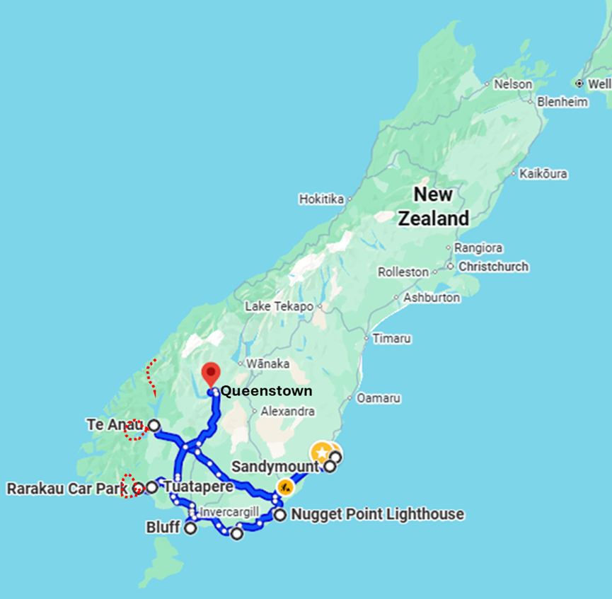
Walking Tracks and Driving Routes on the Main Itinerary
Hump Ridge Track
Kepler Track
Milford Track

- Our first two treks – the Milford and Kepler “Great Walks” – will go from days 4-11 with a rest day between them to resupply, relax or take a bike ride by the lake, and eat some amazing food in Te Anau. These treks are renowned as some of the best in the world.
  - Our 3-day Kepler Track will begin with a water taxi ride across Lake Te Anau to Brod Bay, from which we’ll climb through thick native forest to the treeline and then ramble high through the alpine tussock to Luxmore Hut, with 360-degree views of the lake and its many arms arrayed below us. We’ll watch for the resident Keas (alpine parrots) and visit the local caves and peak if weather permits. (4.8 miles, 2821 feet gain, 95 feet loss, Moderate difficulty).
  - Day 2 of the Kepler Track is some of the best ridge walking on the planet. We’ll climb to the ridge from Luxmore Hut, then follow successive open ridges for miles far above the arms of Lake Te Anau before descending steeply on steps and trail and walking through lush forest to Iris Burn hut and a chance to go out after dark to find elusive Kiwis! (8.75 miles, 2174 feet gain, 4027 feet loss, Moderate difficulty)
  - The last day of the Kepler track is a full immersion in New Zealand’s native forest, mostly flat walking, surrounded by the sounds of rare songbirds, and with a chance for a lunchtime dip in Lake Manapouri, before catching a bus back to our hotel in Te Anau. (13.7 miles, 951 feet gain, 1829 feet loss, Easy).
  - Our 4-day Milford Track will begin with a scenic bus and boat ride from Te Anau along huge Lake Te Anau to a wharf on the opposite side, from which we’ll walk on gentle trail along the Clinton river in lush riparian forest to the Clinton Hut (3.1 miles, 122 feet gain, 76 feet loss, Easy).
  - Day 2 of the Milford Track continues up the Clinton River under steadily rising cliffs and gorgeous waterfalls, mostly in lovely native forest (listen for the songbirds here!) on still gentle but steadily rising trail, to the Mintaro Hut. (11.6 miles, 1656 feet gain, 324 feet loss, Moderate difficulty).
  - Day 3 is the crux of the Milford Track as we hike toward the Clinton headwall and then steeply up and over 3790-foot Omanui/McKinnon Pass, discovered by Quintin McKinnon in 1988 on a search for a tourist route between the Clinton and Arthur River valleys from Lake Te Anau to Milford Sound. The ridge from the pass and the descent along the Arthur River headwaters (with a side trip to Sutherland Falls) to Dumpling Hut are magical! (11.1 miles, 2367 feet gain, 4022 feet loss, Moderate to Strenuous).
  - The last day of the Milford Track is a peaceful, gentle walk along the Arthur River in more lush native New Zealand rain forest, ending at Sandfly Bay on the majestic Milford Sound. We’ll cross on a ferry to Milford Village and catch a cruise boat to go up the sound (under majestic vertical granite walls gushing with waterfalls) to the Tasman Sea, with luck seeing fur seals, dolphins and penguins along the way! After the cruise we’ll take a bus back to Te Anau for the night. (11.4 miles, 557 feet gain, 944 feet loss, Easy-Moderate difficulty).
- After returning from the Milford track and spending a morning for laundry and resupply in Te Anau, we’ll set out for three days driving and day-hiking through the wild and dramatic landscapes, rugged coastlines, rolling hills, lighthouses and waterfalls of the Southern Scenic Route through the Otago Peninsula, the Taranaki range, the Blue Mountains and the Catlins coast. Along the way we’ll visit a Royal Albatross center and breeding area and a rehab center for Yellow-Eyed and tiny Blue penguins, hiking to a remote bay to look for penguins climbing a cliff from the sea in Sandfly Bay to lay their eggs and to watch for endangered New Zealand fur seals, Hooker's sea lions, and Hector's dolphins. From there we’ll drive east along the southernmost coast of New Zealand with hikes to a remote lighthouse at Nugget Point, a petrified forest at Curio Bay, and the furthest south point on the South Island at Bluff, ending at the small town of Tuatapere, the gateway to our last trekking route – the Hump Ridge Great Walk.

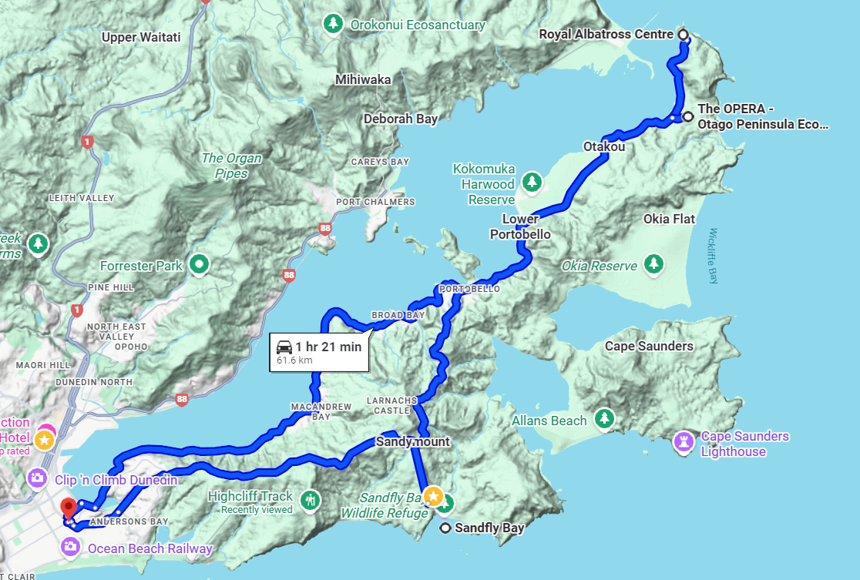
Driving-Touring Route on the Otago Peninsula

  - Day 1 of the Hump Ridge track departs from a parking area about 15 minutes out of town, and follows the beach for 4 miles before heading into gorgeous tree fern and Southern Beech forest and then turning steeply uphill at about mile 8 to push 4 miles further on rugged rooty trail and boardwalk to Okaka Lodge, on the treeline. After settling into the hut, we’ll explore high above the lodge (for sunset or the next morning’s sunrise) to loop around spectacular rock formations and several crystal clear alpine tarns, with panoramic views over the Southern Ocean including Stewart Island in the distance. (11.8 miles, 3491 feet gain, 650 feet loss, Strenuous to Very Strenuous).
  - On Day 2 of the Hump Ridge track we’ll descend through gnarled southern beech forest with openings to views out over the Southern Ocean, to join the South Coast track and cross three historic wooden trestles following an old logging route to Port Craig Hut with its abandoned wharf. (swim here with a pod of Hector’s Dolphins – if you care to brave the swarms of sand flies!) (12.6 miles, 1108 feet gain, 3950 feet loss, Moderate-Strenuous).
  - The final day of the Hump Ridge track is a glory of dappled tree-fern forest and beach walking on rolling terrain back to the parking area, where we’ll pick up our vehicle to drive 2.5 hours back to Queenstown for a last night before catching our flights home or onward through Auckland the next day. (12.1 miles, 1115 feet gain, 1083 feet loss, Moderate difficulty).

Optional North Island Extension for Participants in the Main Itinerary
- An optional 8-day excursion on the North Island before the main itinerary will offer a chance to explore the lovely Auckland harbor district, to visit Rotorua and it’s colorful thermal areas (and huge lake with black swans!), to experience local Maori food and culture, and to complete a memorable four-day trekking loop (31 miles, 6000 feet of total gain and loss) around a cluster of active volcanoes, volcanic dikes and surreal-colored lakes on the Tongariro Northern Circuit (carrying tents, food and overnight gear to camp along the way). Then, on the way back to Auckland for flights to Queenstown to join the Main Itinerary, participants with an interest will have the opportunity to explore the unforgettable limestone caves and underground rivers of Waitomo on their own with glow-worms overhead (there are options for a low-stress float in inner-tubes or rafts through the caves, or more exciting options involving rappelling into the caves and scaling waterfalls, all through a reliable third party company that takes care of safety and logistics).
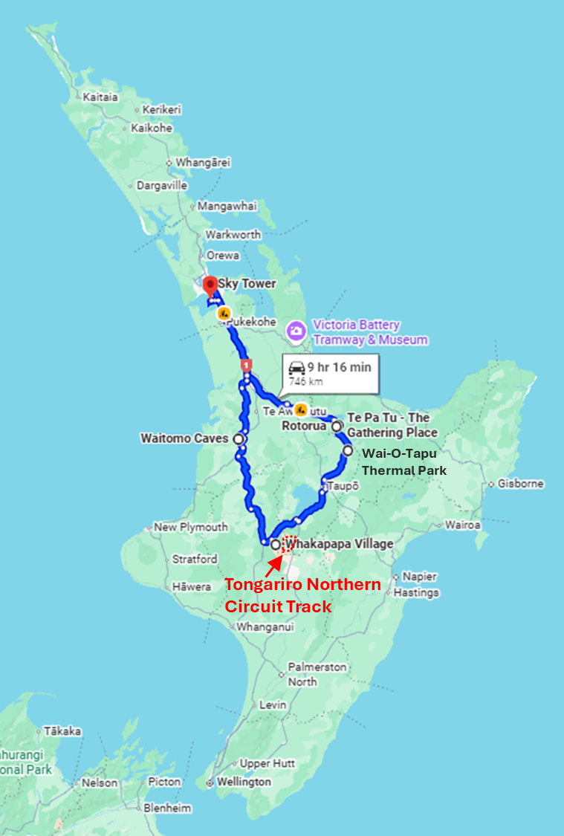
Walking Track and Driving Route on the North Island Extension Itinerary
- Meeting Time and Place:
  - Those signed onto the pre-trip extension will meet the group at the Auckland airport at a coordinated time (if possible) in the morning on February 1, 2027 for a shuttle together to the Auckland harbor area and check in to our hotel (night included). (Note this requires a departure from Seattle on January 30, 2027 because we cross the international date line.) Anyone who arrives at a very different time than the others or whose flight and/or bags are delayed will be able to get to the hotel easily on their own by taxi or bus.
  - Everyone on the pre-trip extension will continue to the Auckland airport together, stay at a hotel near there (included), and board the same morning flight to Queenstown on February 9, 2027 (we will all buy our own flight tickets to Queenstown).
  - Those on the Main Itinerary who are NOT on the pre-trip extension will need to depart Seattle on February 7, 2027 to arrive in Auckland in the morning on February 9, 2027 and catch a flight that same day to Queenstown. To the extent that everyone can arrive at the same time in Queenstown, a shuttle will be arranged for everyone to ride together to our hotel from the Queenstown airport. Those who are delayed on the way to Queenstown can easily catch their own taxi or ride the shared bus to our Queenstown hotel.
  - We will all spend the night together at the same hotel in Queenstown on the last night (February 25, 2027) and shuttle together to the airport for flights out.
- Trip Rating: Easy to strenuous/very strenuous
- Time of Year: Our itinerary in February is high summer, with generally warm temperatures and a reduced chance of rainfall but also late enough to avoid the biggest crowds. WARNING: Though this is the best time of year for sun and dry weather in New Zealand, we’ll be traveling in mountain and coast environments where extremes of weather can still occur, so we will all need to be prepared for everything from heat to snow.
- Lodging: Before, between and after our treks we’ll stay in comfortable 3-star lodgings (twin-share basis with en-suite bath) within convenient walking distance of restaurants and local sights. On the pre-trip extension we will stay at hotels in Auckland, Rotorua, Turangi and Waitomo, and on the main itinerary we’ll stay in hotels in Queenstown, Te Anau, Dunedin and Tuatapere. On the Kepler, Milford and Hump Ridge Great Walks we’ll stay in huts with basic dorm-style accommodations, toilets, running water (may not be purified) and gas cookers in the common area for cooking (food and pots not provided). Dorm bunkrooms may be set up with bunkbeds and mattresses (up to 40 in a big room) or with platforms with mattresses set side to side, and we’ll typically be sharing space with trampers of both genders including people from other groups. Single-gender toilet rooms are down the hall, and showers are not available in Kepler and Milford Track huts but are available for a cost in the Hump Ridge huts. During our the Tongariro Circuit we’ll be camping in lovely remote and scenic camps with running water and toilets shared with a nearby (but hot and noisy) hut. Cooking facilities at the huts can’t be used by campers so we’ll be bringing our own stoves and gas.
- Food: When we’re in town, breakfasts will be included at some but not all of our hotels (and lovely cafes are in close walking distance for breakfasts at our own expense when they’re not provided at our hotels). We’ll have a few included group dinners at some of the many fantastic local restaurants while in town, including a traditional Maori feast near Rotorua on the pre-trip extension and a welcome dinner buffet high above Queenstown at the top of a gondola! You’ll be amazed and thrilled by the great food and wine you can find across the country! Lunches and most dinners in town will be on our own to give us some space and a chance to try more different offerings. (Most dietary restrictions can be easily accommodated.). At the huts during our tramping segments, we will provide and prepare our own food, generally purchased from one of the many excellent supermarkets and health food stores that can be found in our gateway towns.
- Leader: Cheryl Talbert has been a hiking and backpacking leader since 2009, and a Global Adventures leader since 2011. She has led a number of extended high-country backpacks in the US as well as successful international trips and treks including Turkey, Spain, Portugal, Norway, Italy, New Zealand, Australia, Belize, Iceland, the Himalaya, southern and northern Patagonia, Jordan, Peru, Kyrgyzstan, Bhutan, Sikkim and Nepal. This will be her seventh trekking trip to New Zealand, her fourth time leading in the country for the Mountaineers.
- Maximum 12 participants, minimum 10 on Main Itinerary.
- Participant requirements: Participants must be Mountaineers members with a current waiver on file. Because participants must carry ~20 pounds of gear and food for 3-4 successive days at a time on sometimes steep and rough, rocky trail, a high level of conditioning, balance and recent multi-day trekking or strenuous hiking experience are required along with the appropriate gear for variable, potentially extreme weather. In addition, this is a group trip (though plenty of opportunities for solitude will be available) so participants must be flexible and accommodating, have a positive attitude, and be able to amicably handle close quarters and the company of others for extended periods. Participants must complete and return a liability waiver and a detailed medical information form, and a doctor’s approval if the leader requests it based on current or recent medical conditions. International medical treatment and evacuation coverage will be required (not included in the trip price).
  - NOTE: Your leader makes most of the arrangements and provides logistics support during the trip, but is NOT a tour guide! As a Mountaineers group we will operate as interdependent, capable travelers making our way together and helping one another succeed and be safe. You must have the ability to navigate on trails with a map and compass.
  - NOTE: Participants must be fully vaccinated to participate in the trip. In addition, participants are expected to practice conservative covid behavior before and during transit to the trip including masking and avoiding crowded indoor spaces whenever possible; and that they will carry covid self-tests on the trip and use them in the week before or any time during the trip when they experience a symptom commonly related to covid. Any positive test or contagious respiratory illness symptoms mean that the participant will need to mask up and isolate as much as possible until they are symptom free.
- Trip Price Detail: $3700 for main itinerary, and $1300 more for the pre-trip extension based on 8 people adding the extension. This includes all lodging, a few meals in town, ground transport, luggage transfers, all required hut permits, and major included tours as well as a portion of the leader’s expenses and a 16% Mountaineers Admin Fee. Not included are the participants’ international airfare (~$1500), airport shuttles, insurance, all food for the tramping segments, all lunches, and some dinners in town, optional activities in town, alcoholic beverages, and any personal items (total ~$1900-2600 depending on the type and amount of insurance and your restaurant choices).
- Registration Instructions: Registration for this trip is unusual, because names must be provided in order to book huts but we can’t post the trip for open registration until huts are booked and the itinerary and price are firm. For that reason, the leader will call for applications from qualified members in early spring 2026 by blog, email and social media and will request firm commitments from approved applicants before the trip is officially posted on the Mountaineers website, and once huts are secured the trip will be posted and the approved applicants will be asked to pay the 50% deposit to get on the roster. Spots on the roster cannot be held without payment of the deposit. Any spots still open after that point will be open for additional applicants. Registration will close on September 1, 2026 or whenever the roster fills. The balance of the trip payment will be due in the fall of 2026.
- Cancellation Policy. Because many of the required advanced bookings are non-refundable, there will not be the option for a refund once people have paid the deposit and joined the roster. The exception is that these fees may be waived other than the minimum $100 Mountaineers Admin Fee if someone registers to take your place.

Not including 3 days flying – two on the way and one back.
Cost extra, to be booked direct with the vendor
Note that the exact itinerary and walks to be included will depend on the leader getting permits which can’t be secured until May of 2026 and can be very competitive.
Called ‘OPERA’ for Otago Peninsula Eco Restoration Alliance – see https://theopera.co.nz/
Cost extra, to be booked direct with the vendor
could be more or less if fewer or more people join

