CREATING AND ACCESSING COMPLETED GLOBAL ADVENTURES FORMS ON ALCHEMER.COM – 5-10-26
Global Adventures uses the survey tools on Alchemer.com to create and share required Global Adventures forms (application, trip agreement, release and supplemental information forms). Then leader must go into Alchemer regularly and check for new responses, particularly when applications are being turned in.
To create a form for your adventure, first log onto Alchemer:
- Type Alchemer.com on your browser
- Click the button to the right for ‘Alchemer survey and Alchemer workflow’
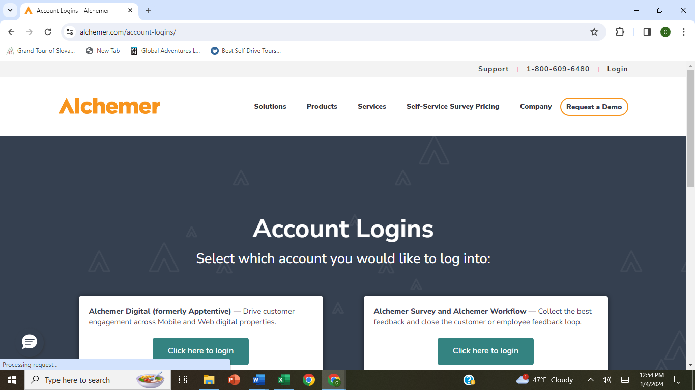
- Log in using username info@mountaineers.org and password branches (all lower case).
- You will then be presented with the directory of Mountaineers forms. Choose Global Adventures on the left-hand nav bar, and in the search box type APPLICATION. Review the existing forms to find a recent one that is in the same activity as your adventure. Make note of the name of that form.
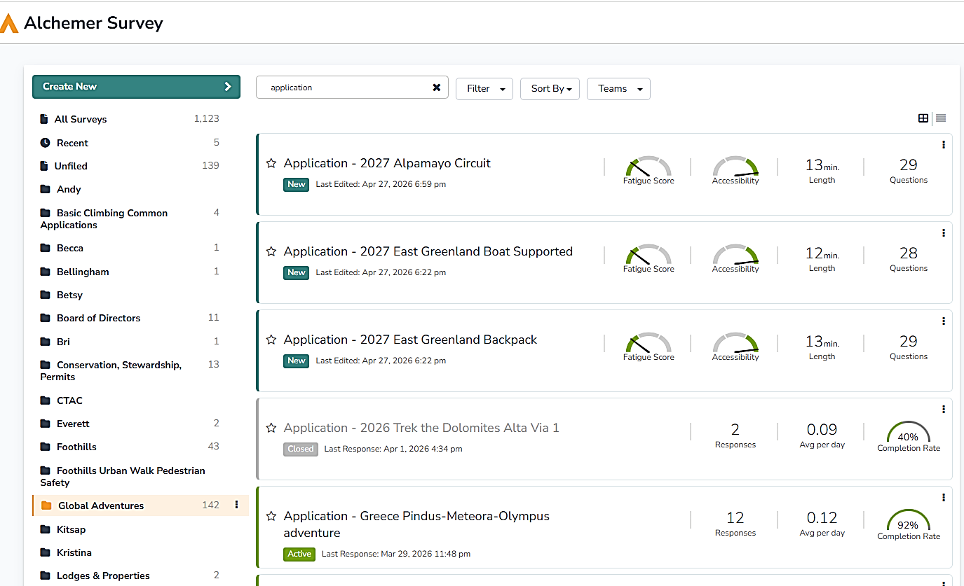
Then click on Create New at the top left, and then check Copy a Survey. This dialog box will come up:
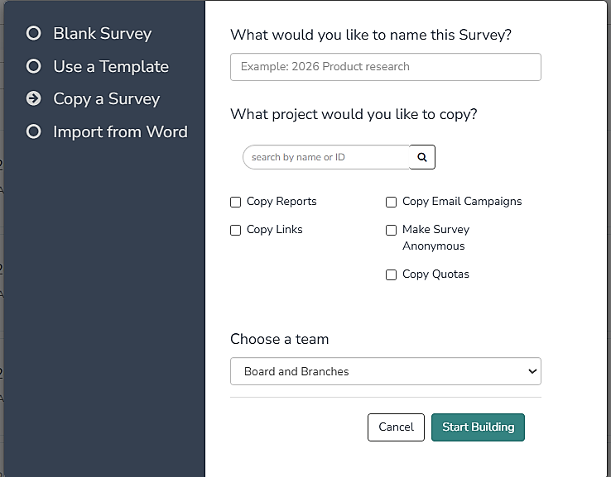
Name your survey with the type of form (Application, Trip Agreement, Release, Supplemental Information), a dash, then a short version of the adventure title. Under ‘what project would you like to copy’, type in the name of the survey you chose in the first step (same form type and a similar activity type). Under ‘Choose a Team’, use ‘Board and Branches’ (will come up by default). Then click on Start Building. The form you chose to copy will be up on your screen, but with your designated new form name.
Read down through each question in the form, and use the Edit button to the right to update the wording to fit your new trip. You can also Remove questions you want to drop, and at the end of each section you can choose Add New and Question to put in another question and move it up to put it in the location in the survey where you want it.
When you are finished editing the form, move back to the top and exit the form, or select SHARE at the top of the form to copy the link to the form.
To access completed forms for your adventure, follow all the login steps as you did for creating a form, including selecting Global Adventures from the left-hand nav, and then use the search box to search for all the forms with your trip name. From this front page you can see how many of each form have been submitted so far.
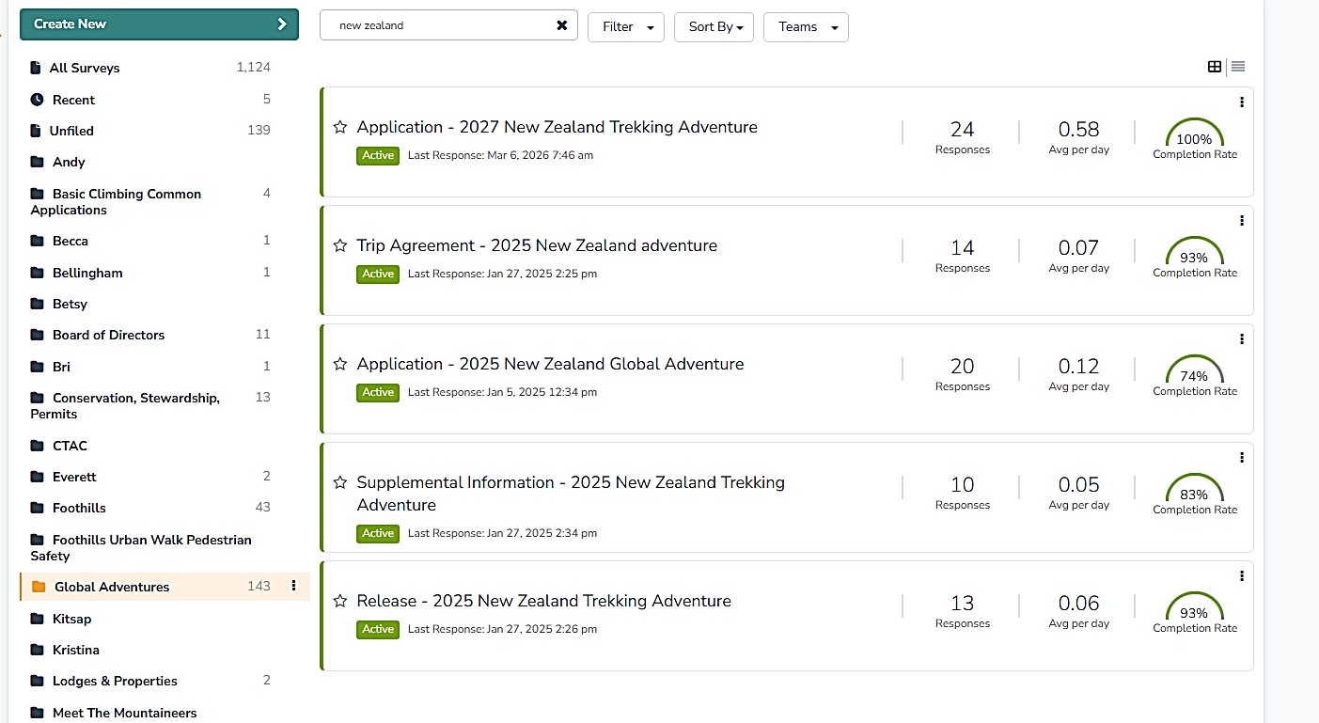
- Scroll down and double click on the form you want. We will use the Application – 2027 New Zealand Global Adventure with 24 entries. The form will come up – click on Results at the top. You can then choose to EXPORT your results in an excel spreadsheet format to access all the details, or to view all the individual responses at a high level to see who has submitted forms so far.
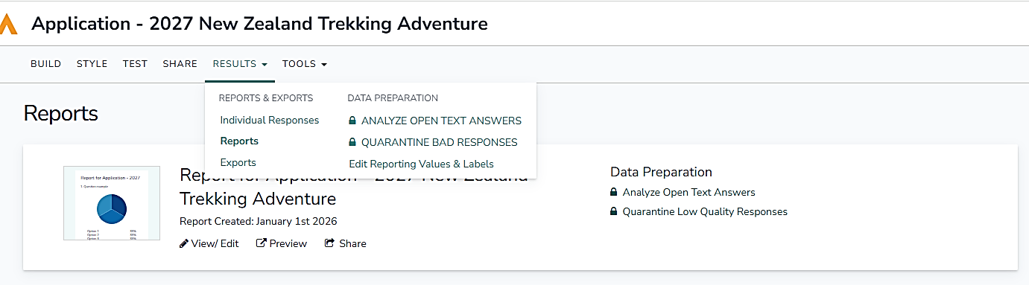
- If you click on EXPORT, you will see the following – choose CSV/EXCEL to get a spreadsheet output:
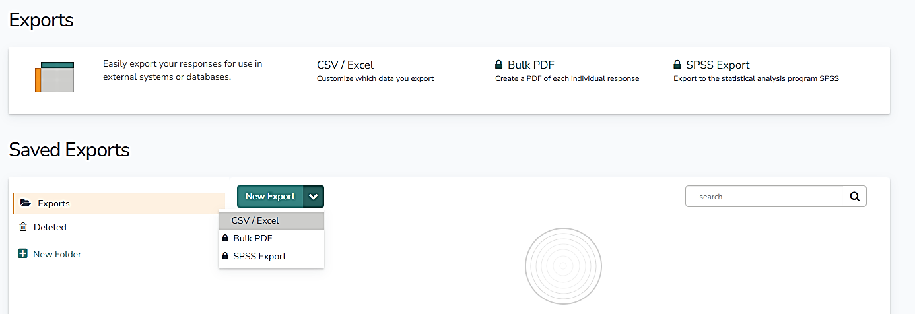
Next you will see the following dialog:
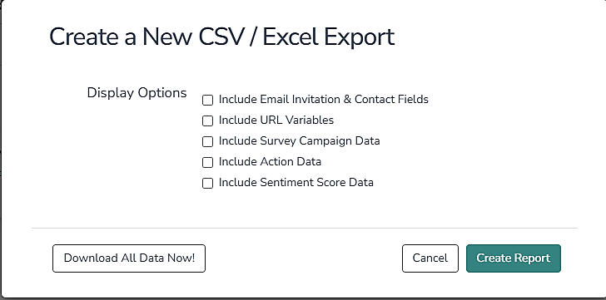
- If you click on ‘Download all Data Now’, a file will appear in your downloads with all of the form information (you may want to delete all the leading info which isn’t useful). If you choose Create Report, Alchemer will generate a formatted report attempting to summarize your responses (this isn’t useful for forms with essay-type answers, but can be useful for some purposes).

- If you instead click on INDIVIDUAL RESPONSES instead of EXPORT, all the responses that have been submitted so far will come up. (Ignore any duplicates and any that are given as Partial.) This is handy so that you can see who you need to follow up with and who has not completed their form yet. You can also double click on any of the individual submissions to see their detailed responses on the form.

Many of the questions in these forms are standard ones and should not be removed unless they clearly are specific to one individual trip, though you certainly can change trip-specific references like distance and terrain as needed. In particular, the RELEASE form should not be changed except to change any reference to the trip name.

