Mountaineer Safety Committee & Branch Safety Officer Information

The Mountaineers Safety Committee is a committee established in 2006 by the Mountaineers Board of Directors following the 2005 Sharkfin Tower incident. 3 Mountaineers were killed in this incident.

The Safety Committee has one primary goal:
To promote a culture of safety within the Mountaineers.

The committee works cooperatively with Activity participants, leaders, committees, and branch chairs to identify areas where safety can be improved. The committee disseminates any findings to the entire Mountaineer community to reduce incidents and accidents to the lowest possible level.

---

The Safety Committee consists of:
- A Safety Officer from each branch
- Branch Chairs
- Activity safety chairs who are active participants in the committee. (Inactive members are dropped.)

All committee members receive an email that is generated whenever the Incident section of a Activity/Trip Report is filled out.

Once a year, usually in January, the Safety Committee meets to examine the previous year’s incidents, and recommend improvements to Mountaineer programs and courses.

Current Committee Activities:
- Produce an annual report of incidents and share with the Mountaineer organization.
- Write Safety Blogs describing past incidents and other safety topics of interest. Submit to staff for editing and publication.
- Share safety information with branch activity committees as requested.
- Perform data analytics on incident data, looking for underlying patterns that are only visible when a large number of incident reports are gathered.
- Maintain the Safety Committee website (in conjunction with staff).
- Maintain the Incident email forwarding rules. As of April 2017, Climbing, Scrambling, and Hiking chairs for all branches are auto-forwarded incidents.

The MINIMUM EXPECTATION from Safety Committee members is to:
- Attend the annual meeting to review the incidents and suggest recommendations - Branch chairs excepted.

---

Branch Safety Officers are chosen by the Branch Chair. This person is the branch representative to the Safety Committee. The Safety Officer is usually a branch officer.

The MINIMUM EXPECTATIONS for branch safety officers are:
- Monitor branch Incidents from all activities. Forward to appropriate activity chair (unless auto-forwarding is in place for that activity).
- Edit branch incident reports by removing participant names, and editing for publication in an annual report. (Major and Significant incidents)
- Attend the annual Safety Committee meeting.
- Take part in quarterly safety officer meetings.
- Attend branch meetings (as many as reasonably possible).
- Take part in fatality investigations as needed.
- Be available to Branch activity committees to describe/explain the Safety Committee findings and recommendations.

---

The Safety Committee suggests that branch safety officers:
- Acknowledge each Incident report stemming from a branch activity.
- Occasionally ask others taking part in the activity to provide their viewpoint as to what happened. Consider making the request when the situation is complicated/involved and views from others are useful to understand the full story.
- Prepare a version of the incident report with participant names removed or disguised (Major, Significant, and perhaps interesting incidents.)

Below is a template I used as Seattle Safety Officer to make acknowledging Seattle incidents easier (for me). I used ‘#’s to indicate fields I needed to supply before sending.
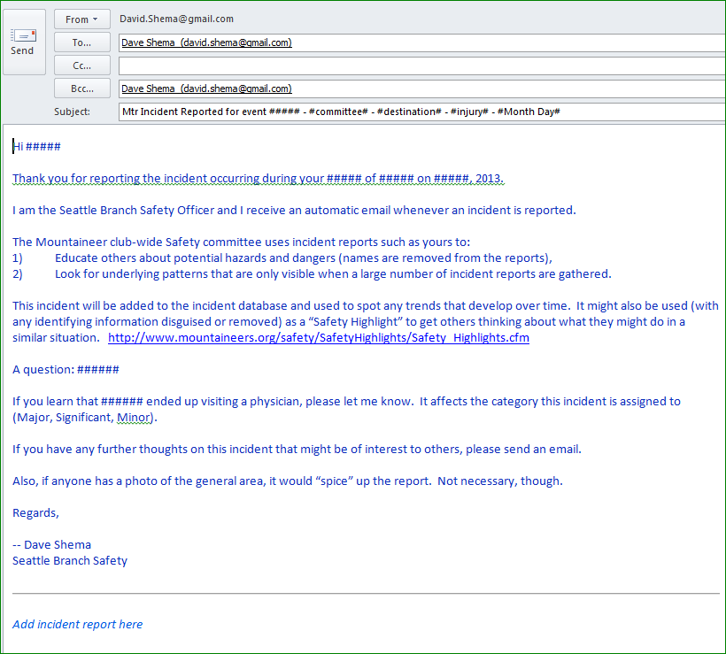

Revised 02 April 2017 – D Shema

