Safety Committee Teleconference. 7:15PM Monday, 28 March 2016
Start: 7:15pm
Attendees (7): Dick Lambe (Foothills), James Pierson(Bellingham), Tom Pearson (Olympia) Thomas Thrasher (Kitsap), Tony Tsuboi (Everett), Mindy Roberts (past chair), Dave Shema (current chair)
Can’t make it (4): Cheryl Talbert(Glob), Helen Arntson(Sea), Raphi Giangiulio(Tac), Tom Varga(Prop)
Logistics:
- Phone number: 515-739-1020 (non-local), access code: 680993. FreeConferenceCall is the provider.
Any access issues?
- None: Suggestion from James – use Google Docs for screen sharing. Edits to the document are visible to all, in real time. We can try this next time.
News:
- Safety Committee is a subcommittee of the “Branch Leadership Committee”. Tab Wilkins (VP for Branches) is the chair.
- AED installed near water fountain at Seattle building (visible and accessible)
- 2015 Incident Report progress. Mindy finishing up, and first draft available next week.

2016 Incident Reports - Suggestion: prepare Incident write-up as they come in. Consensus: keep things simple until we have better tools for tracking.
- Store processed incident reports as Word documents on Safety section of Mountaineer website in a special committee folder. Dave will set up folder, propose a file naming/storage convention, and ask for comments/suggestions/improvements.
- Dave will create a Word template and ask for comments/suggestions.
- Dave will send descriptive step-by-step guide (sometime within the next week, I hope).

Board of Directors retreat. The retreat had a session whereby participants formed 6 groups and had 7 minutes at each of 6 stations. At each station, the group was to come up with the top 1-3 issues for that topic. Groups could read previous groups’ ideas so they would not be starting anew. At the end of the session, the 3 top issues were selected at each station.
“Promote Culture of Safety” is applicable to the Safety Committee.
- 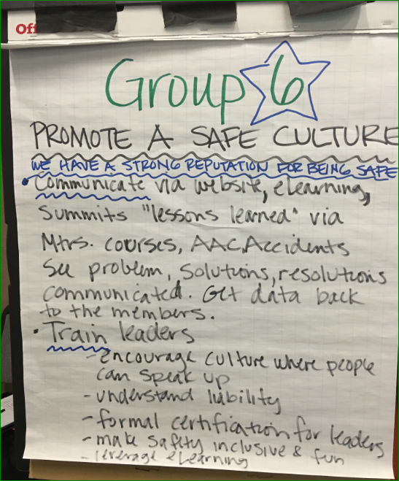
- Mindy – re: training the leaders. Have leaders go thru a short annual review at membership renewal.
  - Use a survey or eLearning or a min-course.
  - Directed to specific activities?
  - Have an overall review and also (perhaps) an in-depth topic for new and interested leaders

Website changes
- New Safety page under review by Kristina. (I have not heard anything in the last week on this.)
- Incident Reports now from both Leaders and Participants
- Safety Reports (from trip participant surveys) no longer contain any details. Shall they be filtered from emails?
  - UPDATE: All Safety Report emails are now diverted into a folder on the Safety Email account. I am monitoring this folder to see how many Safety Concerns (as indicated on the participant survey) result in participant incident reports.
  - Will participants who just filled out the trip survey also be willing to fill out an incident report?

Proposed Next Steps for Safety Committee?
- Improve Culture of Safety - how best to do this?
- Website improvements - try to get additional fields added to Incident Report. This should be easy to do.
- Website improvements - Obtain better tools for tracking reports.
- Dave – Confer with Tab and Branch Leadership Committee on their expectations for the Safety Committee
- Mindy- Going to meet with Tom Vogl about difficulties in getting our voice heard. Need tools, need improvements to incident report. Dave to do the same with the Branch Leadership Committee.
- Dave and James – see if we can get additional fields added to the incident report to help better categorize the data.
Next meeting in early June.
- There will be a Doodle poll to pin down the best date.
- James will set up a Google Docs to use in lieu of screen sharing and we shall see how well that works.

