BOOK BUNDLES

Purchase all of a multi-volume or multi-series set of books and receive a discount on a “Book Bundle.”

- 30% off for members
- 10% off for non-members

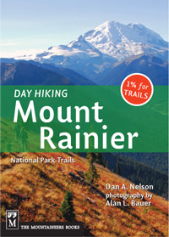
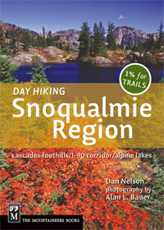
Day Hiking Series Bundle

Day Hiking Central Cascades
Day Hiking Columbia River Gorge
Day Hiking North Cascades
Day Hiking Mount Rainier
Day Hiking Olympic Peninsula
Day Hiking Snoqualmie Region
Day Hiking South Cascades
Day Hiking Eastern Washington
Backpacking Washington (optional)

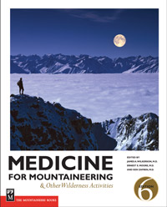
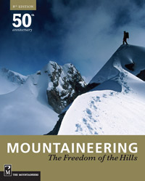
Mountaineering Bundle
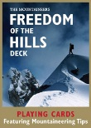
Mountaineering: The Freedom of the Hills
Freedom of the Hills Deck
Medicine for Mountaineering

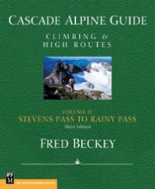
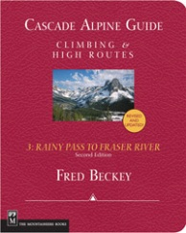
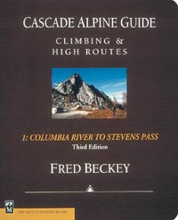
Cascade Alpine Guide “Beckey” Bundle

Cascade Alpine Guide, Vol. 1
Cascade Alpine Guide, Vol. 2
Cascade Alpine Guide, Vol. 3
Challenge of the North Cascades (optional)

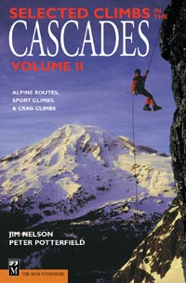
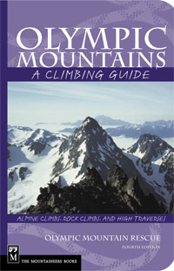
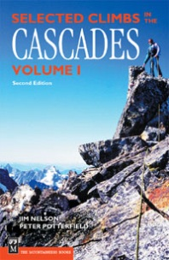
Cascades & Olympics Climbing Guide Bundle

Selected Climbs in the Cascades, Vol. 1
Selected Climbs in the Cascades, Vol. 2
Olympic Mountains: A Climbing Guide
Mount Rainier: A Climbing Guide (optional)
Weekend Rock: Washington (optional)
Washington Ice (optional)

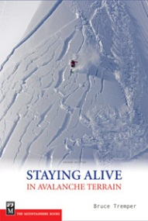
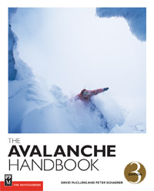
The Avalanche Bundle
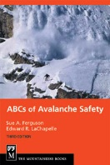
The ABCs of Avalanche Safety
Staying Alive in Avalanche Terrain
The Avalanche Handbook

Skipstone Bundle
Choose six or more of the 33 titles from our Skipstone imprint, books for those who embrace an outdoor lifestyle.

MOES Bundle (Mountaineers Outdoor Expert Series)
Choose six or more of these titles:
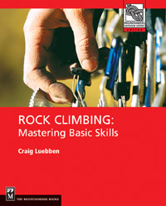
Alpine Climbing: Techniques to Take You Higher
Backcountry Skiing: Skills for Ski Touring and Ski Mountaineering
Big Wall Climbing: Elite Technique
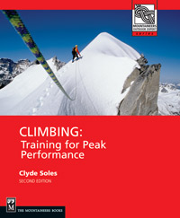
Bouldering: Movement, Tactics and Problem Solving
Climbing: Expedition Planning
Climbing: From Gym to Crag
Climbing Self-Rescue: Improvising Solutions for Serious Situations
Climbing: Training for Peak Performance
Cross-country Skiing: Building Skills for Fun and Fitness
Free-Heel Skiing: Telemark and Parallel Technique
Glacier Travel & Crevasse Rescue
Gym Climbing: Maximizing Your Indoor Experience
Ice & Mixed Climbing
Rock Climbing: Mastering the Basic Skills
Rock Climbing Anchors: A Comprehensive Guide
Snow Travel: Skills for Climbing, Hiking, and Moving Across Snow
Snowboarding: Learning to Ride from All-Mountain to Park and Pipe
Snowshoeing: From Novice to Master
Sport Climbing: From Top Rope to Redpoint, Techniques for Climbing Success

